What is regression?

Regression is a common and easy type of predictive analysis of data that has already been collected. The data being the independent variable (X) and the dependent variable (Y). It is done by analysing the data and plotting a regression line that best represents the data, this can be done to different degrees based on how the data can naturally be interpreted. For example, if the data can be seen to have a natural curve then you would use the 2nd degree.

Regression degrees corresponds to the length of the polynomial function, meaning the highest index of the X variables in the polynomial function. e.g. Degree 2 is a function $y_{n}=w_{0}+ w_{1}x_{n}+ w_{2}x_{n}^{2}$ where *yn*and *xn* are the corresponding dependent and independent variables and the *w* variables are the different coefficients for each x.

Linear regression can be split up into 2 types of models, simple and multiple. Simple linear regression is a simple line plot, it looks at how a single independent variable can show or predict the value of the independent variable, following the function template of: $y_{n}= w_{0}+ w_{1}x_{n}$. This works for when data follow a linear pattern and growing the independent variable produces a linear dependent variable pattern. The second type, multiple linear regression, is for when the data does not follow a simple linear patter and instead shows a curving pattern in the data. It These line follow the function template of: $y_{n}= w_{0}+ w_{1}x_{n}^{1}+ w_{2}x_{n}^{2}+…+ w_{m}x_{n}^{m}$, since the function is not a set length, the complexity of the line and the number of maxima and minima can theoretically be infinite. The higher the degree the closer the regression line will fit to the data. You can get the weights from 2 different ways. If you want a first degree polynomial then you can use gradient decent, which the formula is:

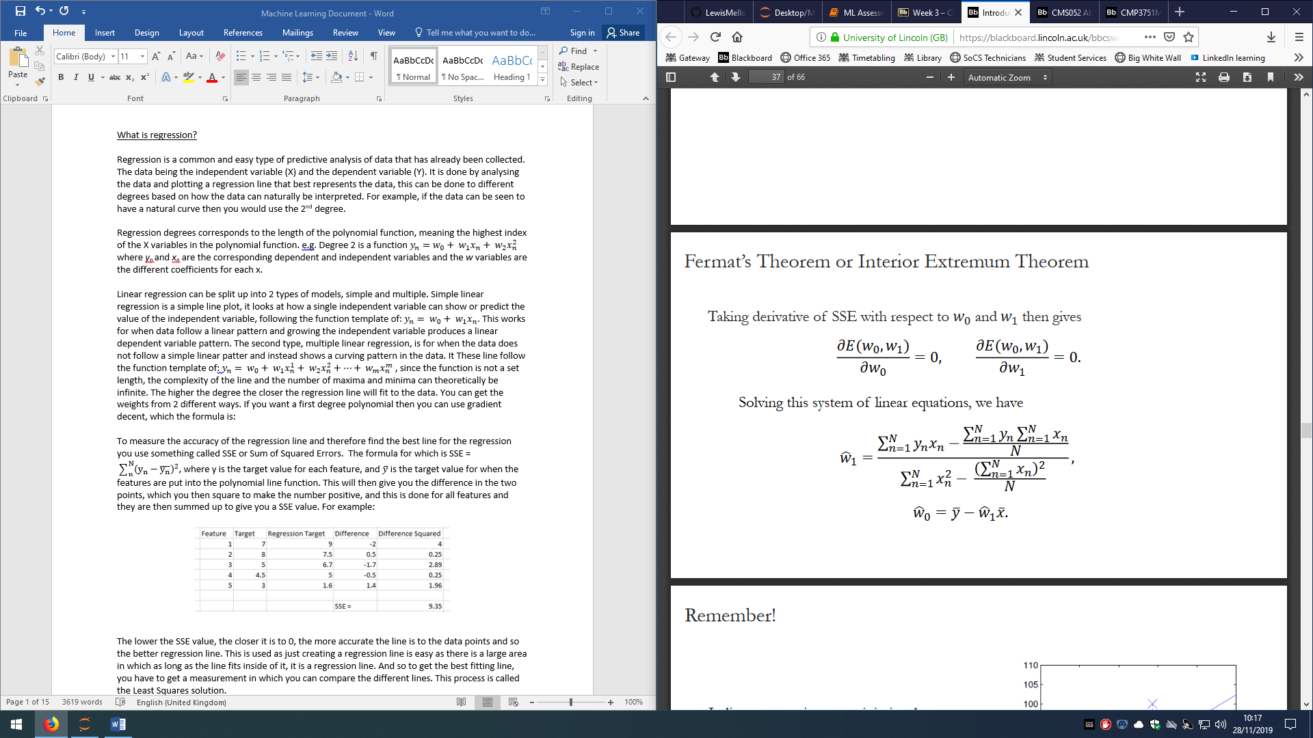

Where xn and yn are the X and Y coordinates of a point. This gives you the second weight. You then input that value plus the means of the x values of the points and the mean of the y values of the points. This gives you the 2 weights you need to make a first degree line.

For multiple linear regression it is a bit more complicated, you create a Vandermonde matrix with a set of X values which produces a matrices where every row is dedicated to a single x value and every column is the x value to an increasing power until it reaches the degree. You then have to solve the linear matrix equation to give you all the weights to the desired degree.

To measure the accuracy of the regression line and therefore find the best line for the regression you use something called SSE or Sum of Squared Errors. The formula for which is SSE = $\sum_{n}^{N}{{\left(y_{n}-\overline{y_{n}}\right)}^{2}}$, where y is the target value for each feature, and $\overline{y}$ is the target value for when the features are put into the polynomial line function. This will then give you the difference in the two points, which you then square to make the number positive, and this is done for all features and they are then summed up to give you a SSE value. For example:

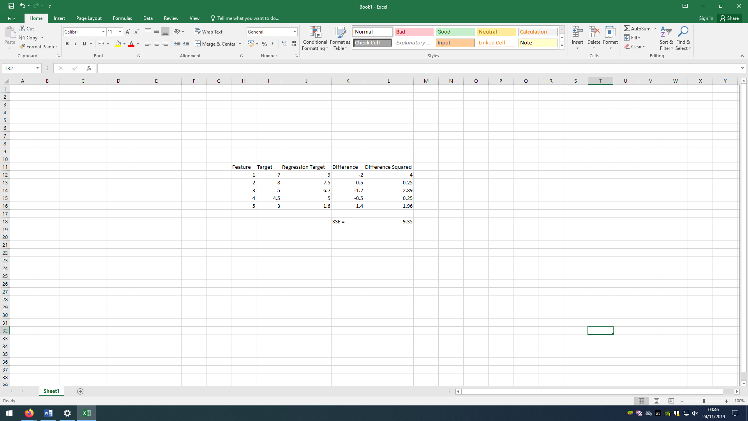

The lower the SSE value, the closer it is to 0, the more accurate the line is to the data points and so the better regression line. This is used as just creating a regression line is easy as there is a large area in which as long as the line fits inside of it, it is a regression line. And so to get the best fitting line, you have to get a measurement in which you can compare the different lines. This process is called the Least Squares solution.

An error function is a function to measure how well the regression line fits the data points. There are several different functions used including RMSE, R2, MSE and SSE, however, the main ones used are RMSE and R2. RMSE stands for Root Mean Squared Error, this is an expansion of MSE (Mean Square Error) which in itself is an expansion of SSE. SSE has been explained above, MSE is just the mean value of SSE with the formula: MSE = $\frac{\sum_{n}^{N}{{\left(y_{n}-\overline{y_{n}}\right)}^{2}}}{N}$ giving you the average of the error distance. MSE can then be expanded into RMSE (Root Mean Square Error) by square rooting the mean of SSE(MSE). Giving the formula: RMSE = $\sqrt{\frac{\sum_{n}^{N}{{\left(y_{n}-\overline{y_{n}}\right)}^{2}}}{N}}$. This gives you a single value which is the exact average value of the lines error. This is known as the absolute measure of fit. The other method, R2, gives you a relative measure of fit(3). R2 is measured using SSE and SST (Sum of Square Total) which formula is very similar to SSE: SST = $\sum_{n}^{N}{{\left(y_{n}-\overline{y}\right)}^{2}}$, where $\overline{y}$ is the mean of all the target values. R2’s formula is: R2 = giving you a number between 0 and 1 where 0 means it is a very poor fitting line for the data and 1 being an exact fit of the data. For our regression function we used RMSE as it is an exact measure of the error and fit of the line.

Polynomial feature expansion is when you increase the number of features and the indices related to it. For example, going from $y= w_{0}+ w_{1}x$ to $y= w_{0}+ w_{1}x+ w_{2}x^{2}$ classes as polynomial feature expansion. This is the equivalent of increasing the degree of the polynomial regression. As explained before, the higher the degree the closer the regression line will fit to the data, however, this is not always good. Regression lines can under fit and over fit. Under fit is when the regression line does not fit the data points in a way that represents the data correctly and using it to predict more targets for new features would create highly inaccurate. For example:

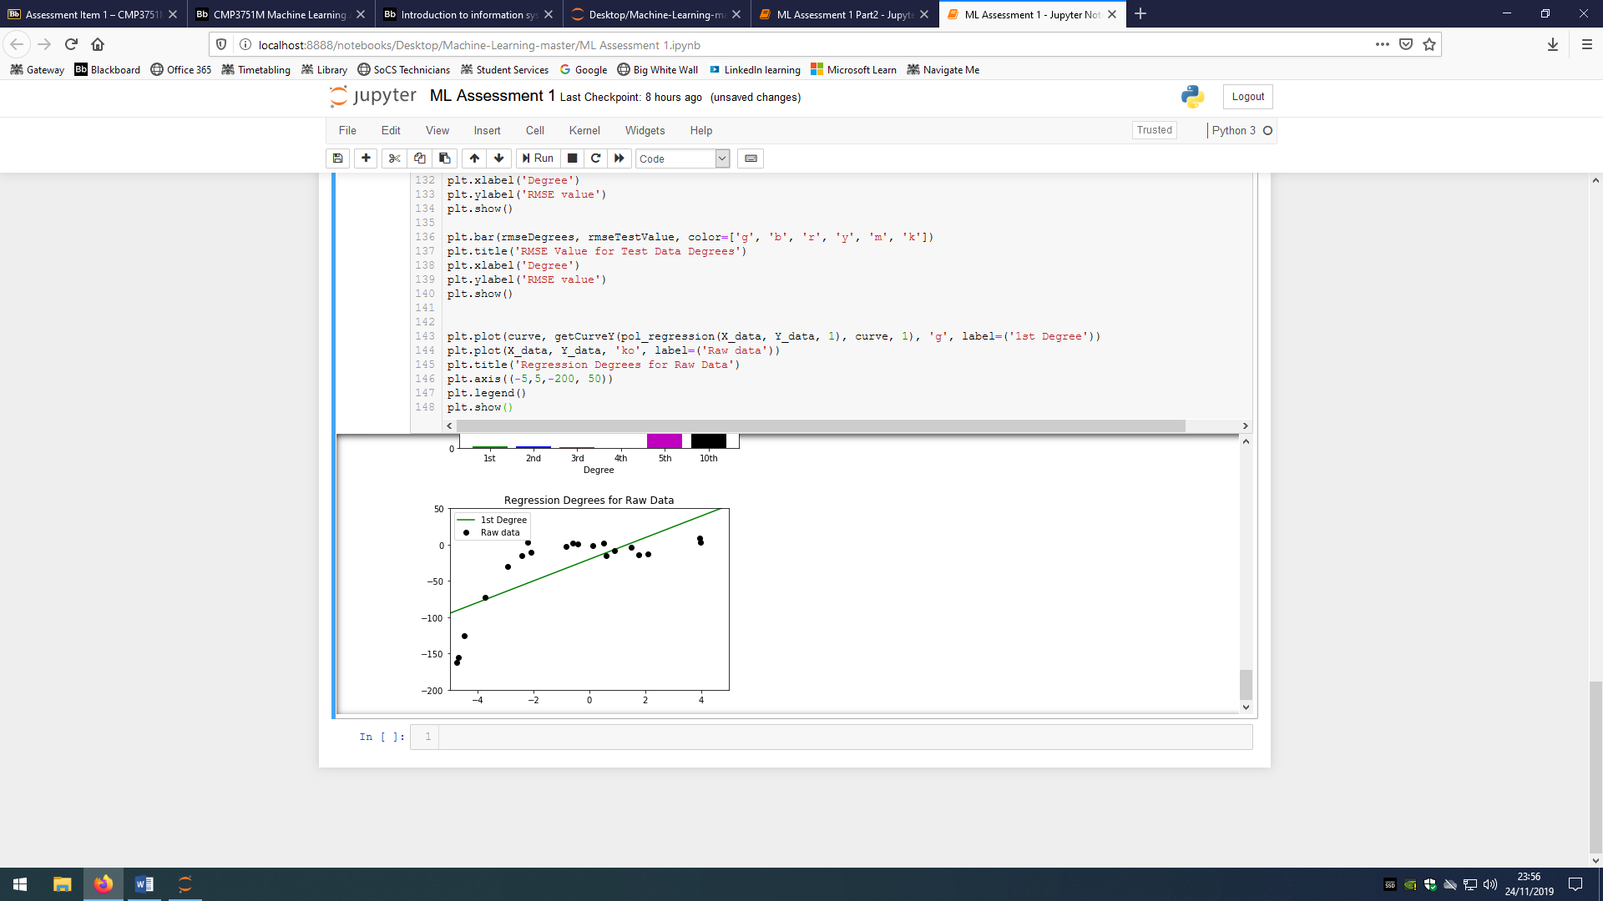

Figure(1) shows a 1st degree polynomial regression line for a set of 20 data points. As you can see, the data has a clear curve pattern to it and the line just cuts through the curve, not accurately representing the data or fitting very well.

This can be quantified in an RMSE value of 35.021 to 3 decimal places, meaning the average error is 35.021.

Figure(1)

On the opposite end of the scale there is over fitting, this is the exact opposite where the degree is so high that the regression line fits too well. The problem with this is that the regression line no longer represents the relationship between the features and the targets and instead represents the random error of the data.(4) if there is no noise then the data would fit a pattern perfectly. Therefore, plotting targets from new features would plot more accurate results than under fitting but would still be inaccurate as the regression line itself has minor errors. For Example:

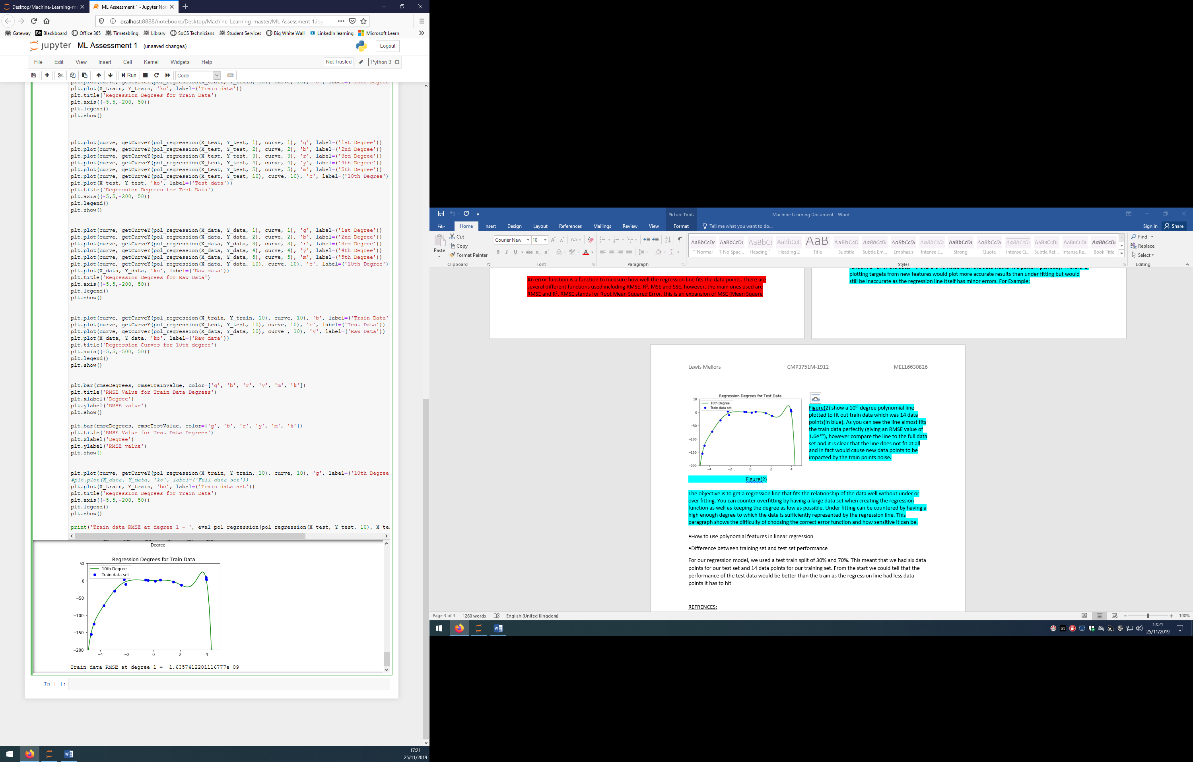

Figure(2) show a 10th degree polynomial line plotted to fit out train data which was 14 data points(in blue). As you can see the line almost fits the train data perfectly (giving an RMSE value of 1.6e-09), however compare the line to the full data set and it is clear that the line does not fit at all and in fact would cause new data points to be impacted by the train points noise.

Figure(2)

The objective is to get a regression line that fits the relationship of the data well without under or over fitting. You can counter overfitting by having a large data set when creating the regression function as well as keeping the degree as low as possible. Under fitting can be countered by having a high enough degree to which the data is sufficiently represented by the regression line. This paragraph shows the difficulty of choosing the correct error function and how sensitive it can be.

For our regression model, we used a test train split of 30% and 70%. This meant that we had six data points for our test set and 14 data points for our training set. We chose the training set from the first 14 points and the test set from the last 6 points of the data set, this was okay as the data was not in order of the x values and was instead randomised. This meant the data points were spread out over the graph which causes the trend of the data to not be lost in either set. If we sorted the data first and then split it, you would get the end few data points to be the test and the beginning of the data to be the train, meaning neither follows the dull trend of the data and so the RMSE values would be very high as the regression line of the train data would not take into account the trend at the end of the graph.

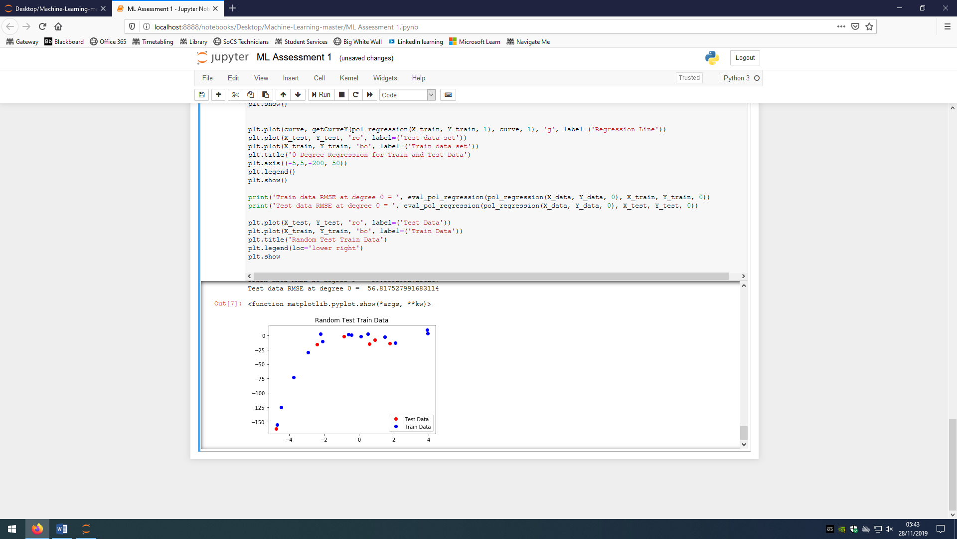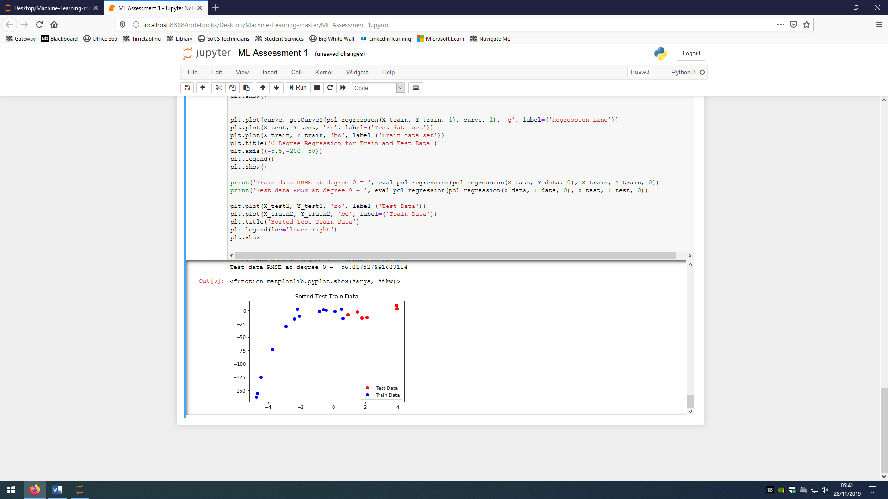

1.2 Implementation of Regression

First of all I imported all necessary python modules. Then we got our data ready. To start we imported our raw data in as a Dataframe. The data is random in this form and so we sort the test and train data first instead of sorting the data to get the full data set then randomising again to get test and train. After splitting the data 70/30 we then sort the data by the X values, this means that when we plot the points on a line graph, it does not make a scribbled mess of joining random dots together and instead joins them corectly increasing in X value. We then split these sets of data into X train and test, and Y train and test. The final 3 lines sorts the raw data by the X and then splits it into

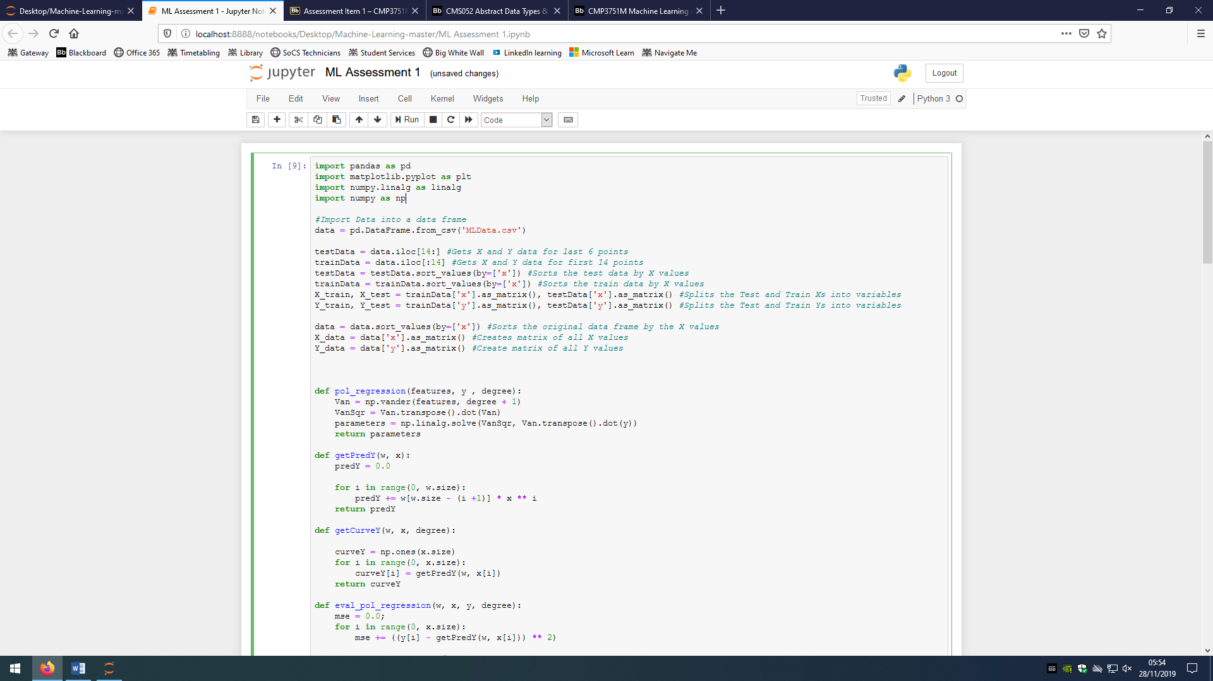X and Y.

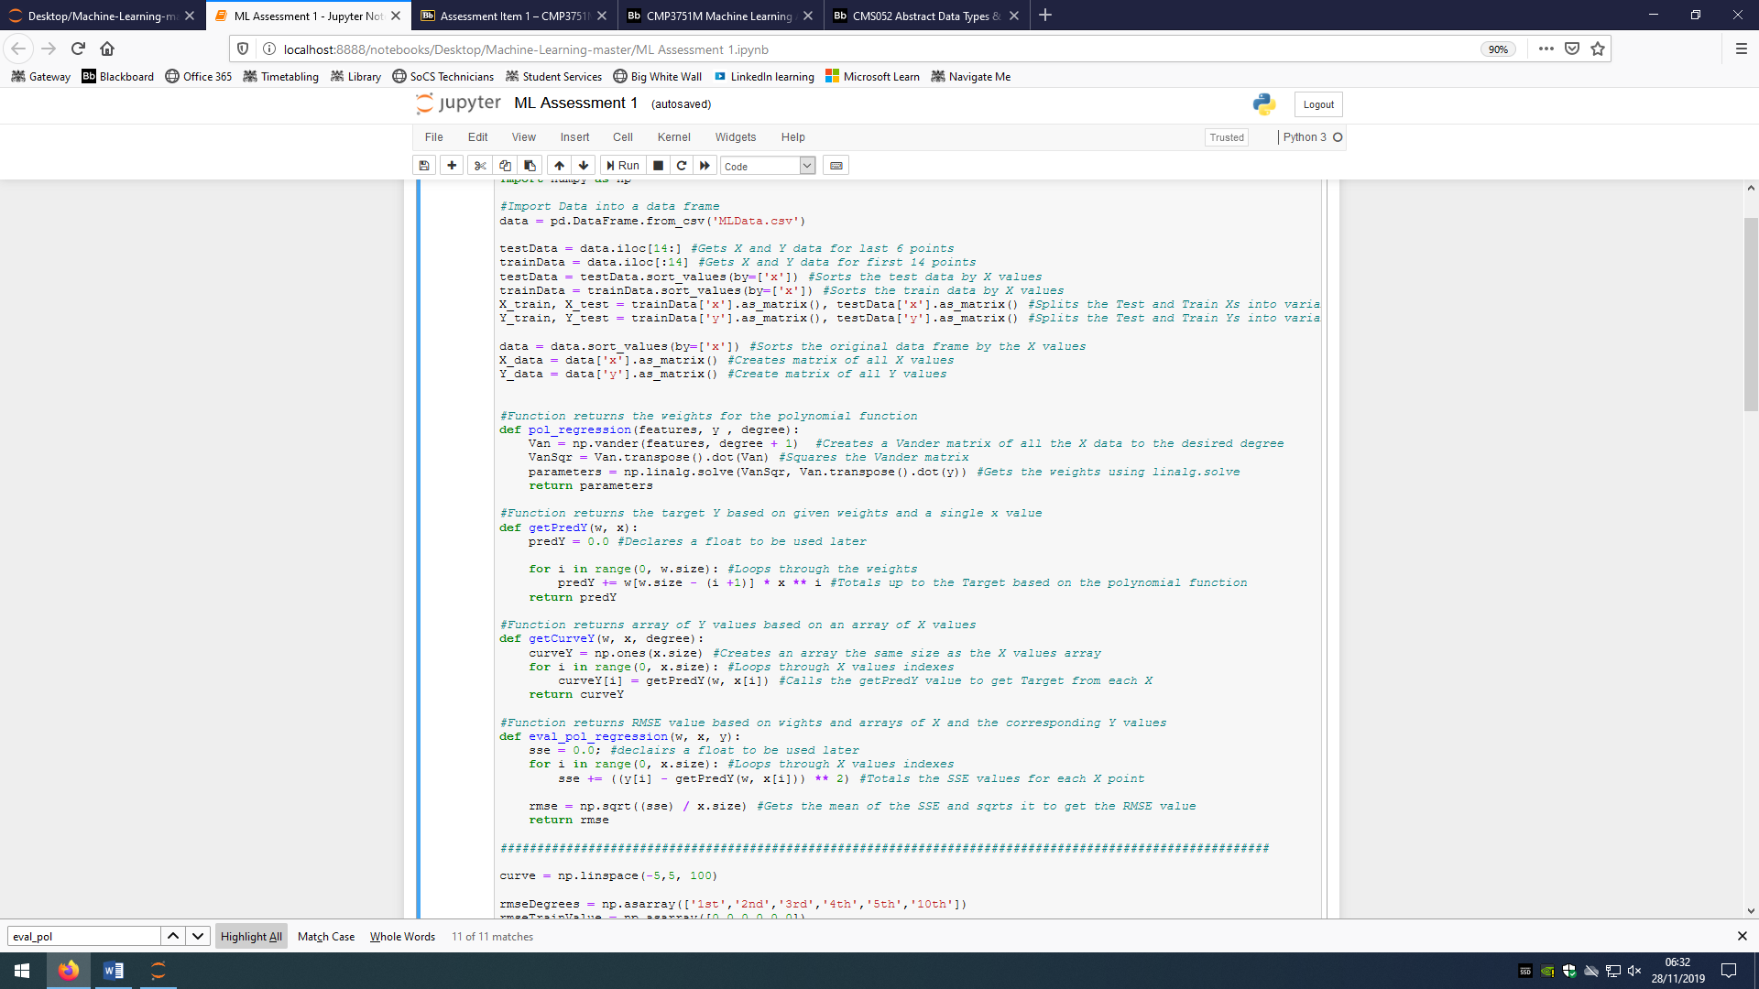The first function gets passed a set of X values, the corresponding Y values and the degree in which you want the regression line to be in. It creates a vander matrix based on the degree given and the X inputs its given. It then squares the matrix by trasposing it. Finally it uses the matricies made and the linalg.solve (least squares) to give the most appropriate weights.

The second function is given the regression weights and a single X value, and returns the Y value of the X point when plotted on the regression line. I used a loop as it meant I would not have to manually input the all the polynomial functions for all the degrees.

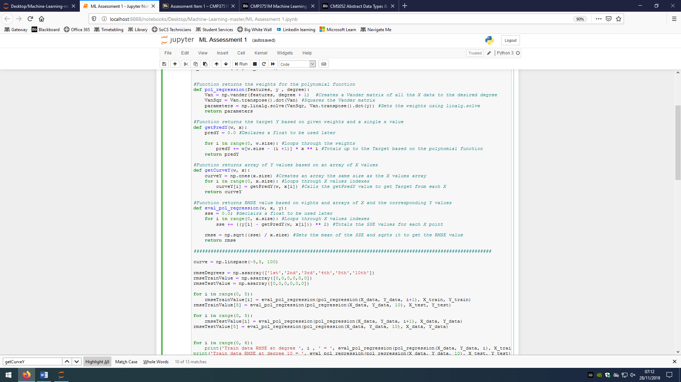The final function is for aesthetic reasons, it is given the weights of the regression line and then an array of X values. It creates an array that will be filled with the Target Y values. It loops through the X values and gets the Predicted Y values based on the regression line by calling the getPredY function.

The next line of code creates 100 values between -5 and 5, these will be used to create a smooth line plot as they represent the X values and we will use the getCurveY function to get the Y values for these points. I have done this because plotting on python just connects the dots, and connecting 14 dots on a large area does not make a smooth graph and so creating 100 points creates a smooth plot.

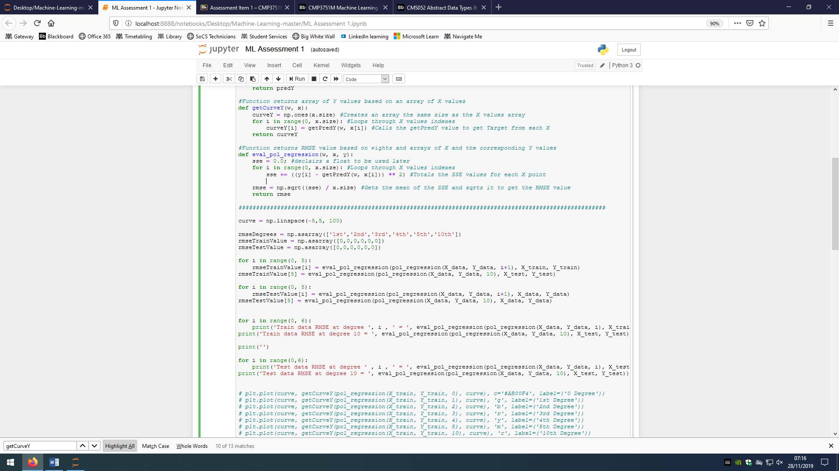

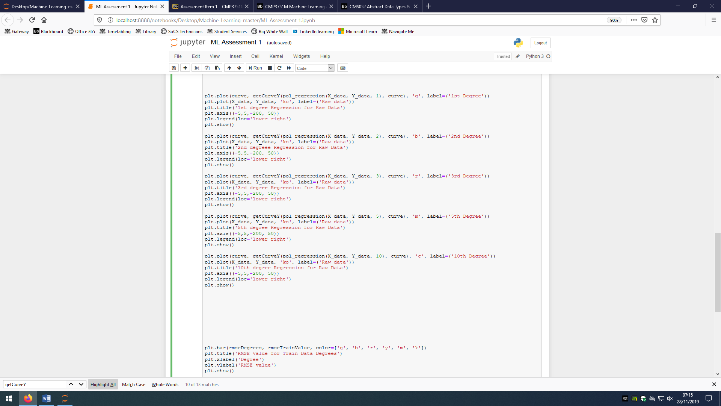The following code just plots the X and Y values for degrees 1, 2, 3, 5, and 10 with the regression weights created by the raw data.

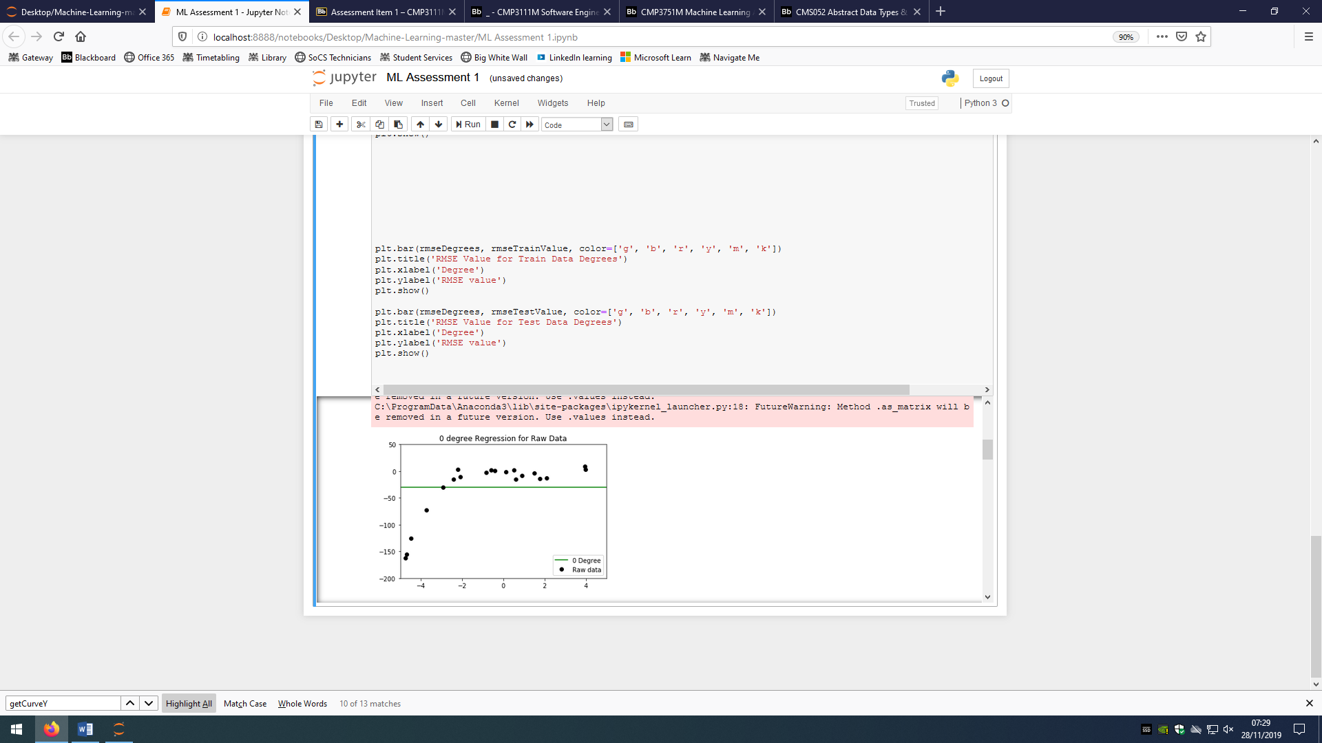

This graph shows the 0 degree polynomial regression for the raw data. It is very clear that the data is under fit as the regression line would just be Y = w. I would never use degree 0 on a 2D plot as in almost all cases there would be a terrible fit to the data.

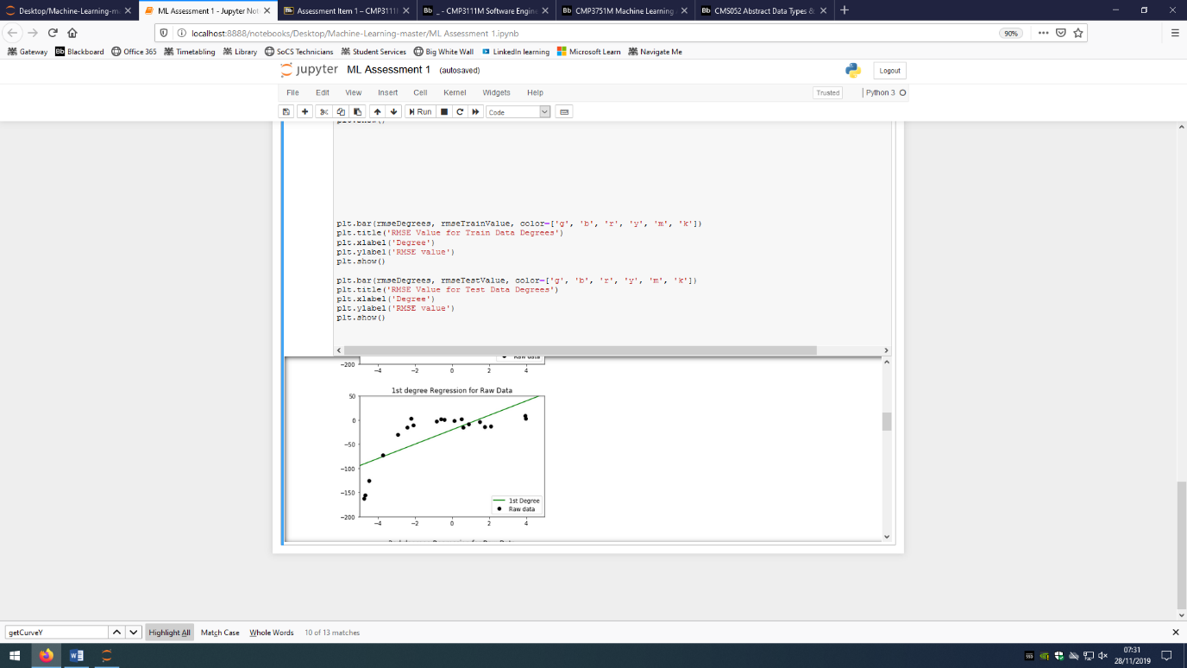

The second graph shows the 1st degree polynomial regression for the raw data. There is still a clear under fit, however, the line does show the positive nature of the data. I would not use this degree polynomial for this data as it would clearly misrepresent the data.

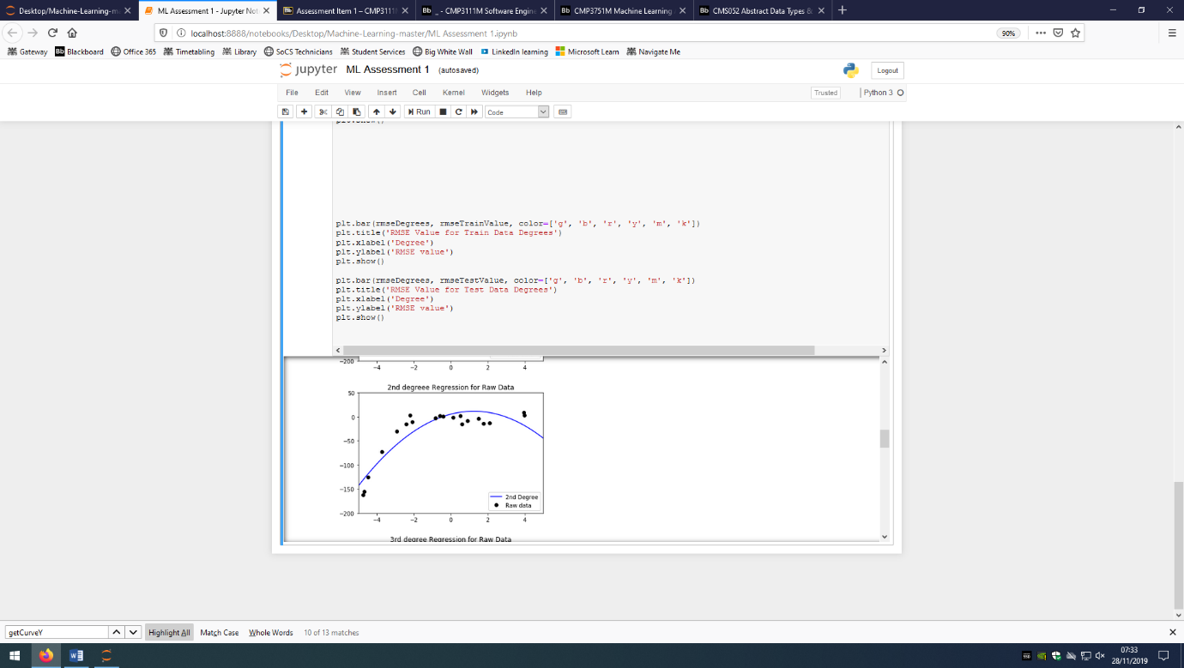

The third graph shows the 2nd degree polynomial regression for the raw data. Again, there is still an underfit as the line does not follow the full trend of the data. But we are getting closer to a good fit. I would still not use this for my regression as there is still a drastic misrepresentation of the data.

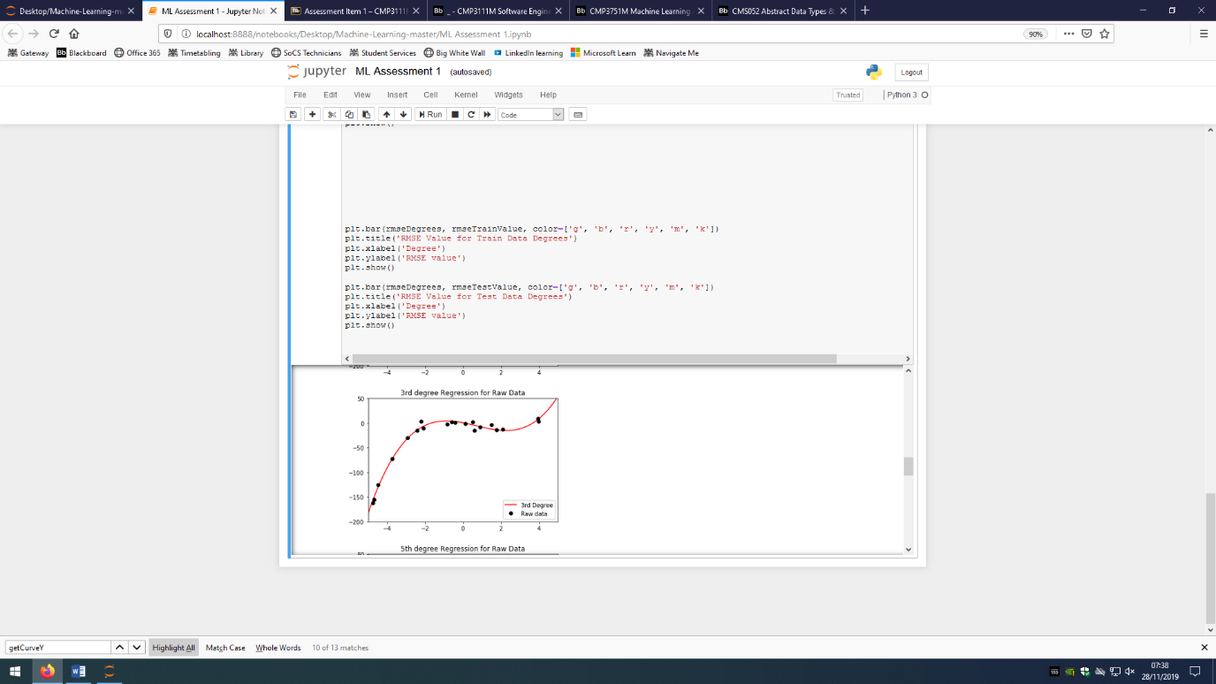

This graph shows the 3rd degree polynomial regression for the raw data. We now have a decent fit of our line to the point, the data is now being represented well and I would consider using this as my regression as from the naked eye is fits the data well.

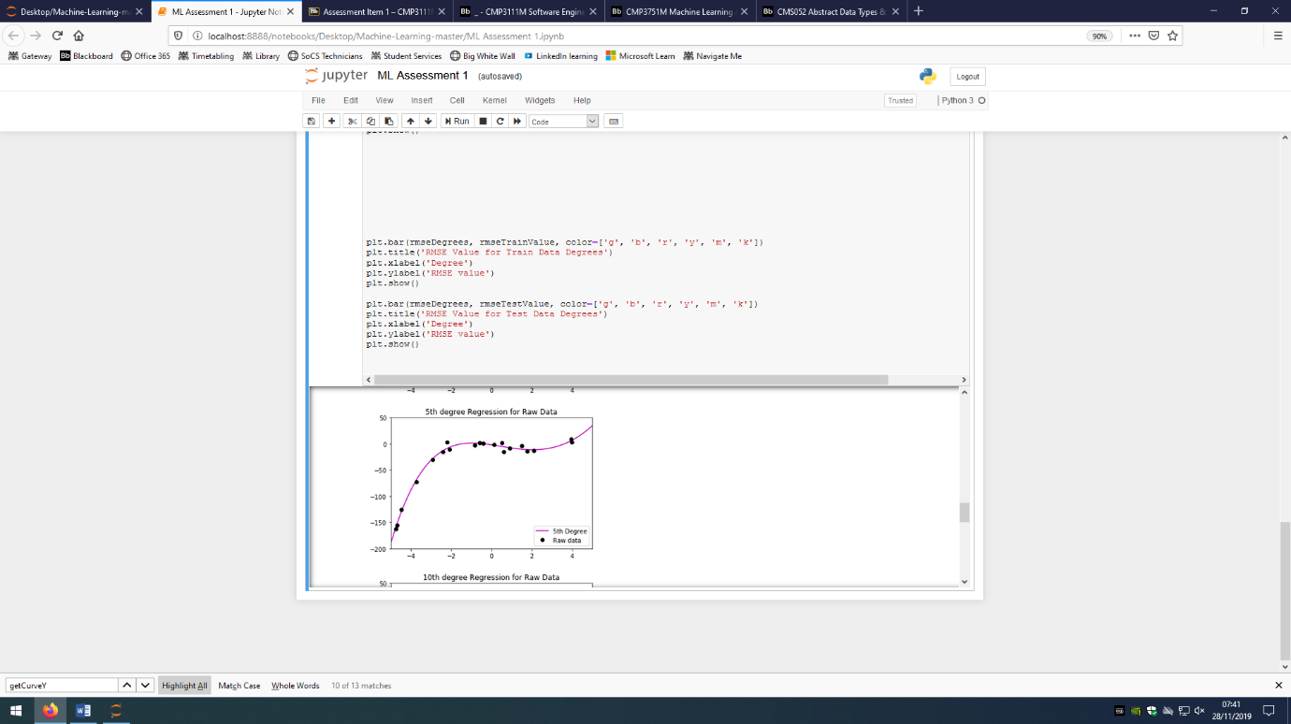

This graph shows the 5th degree polynomial regression for the raw data. There are very subtle change between the 3rd and 5th regression lines. Again the data is represented well and I would consider using this for my regression, however, just from looking at the lines I am unable to see which is better between 3rd and 5th.

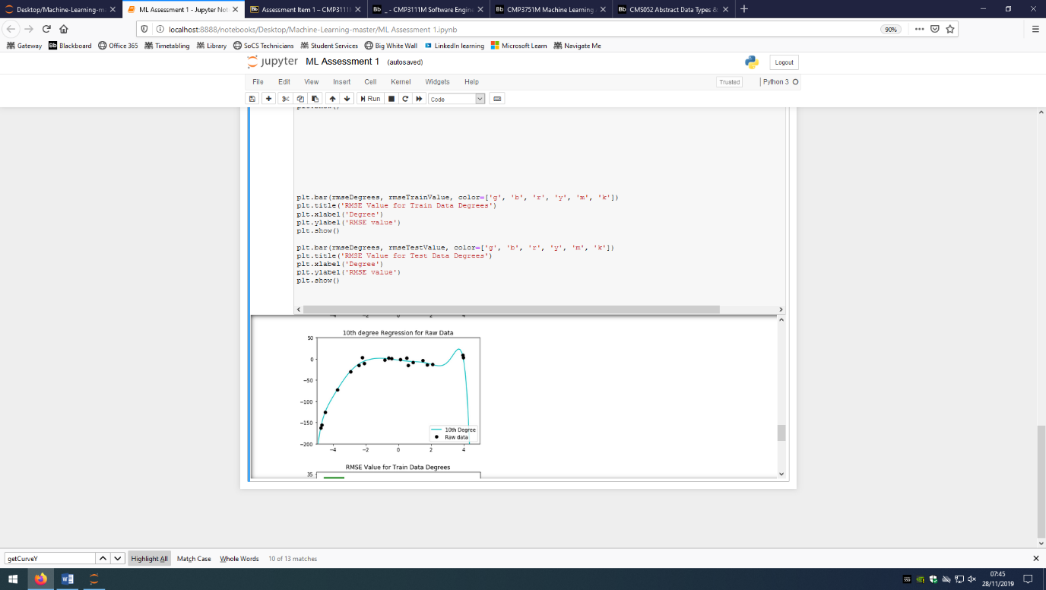

The final graph shows the 10th degree polynomial regression for the raw data. This has now passed a good fit and is now showing over fitting of the data. I would not use this regression as it would no longer represent the data trend and instead would represent the error in the data.

1.3 Evaluation of Regression

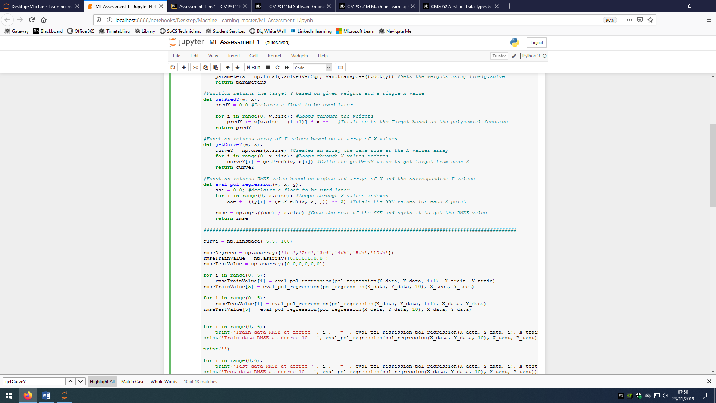We add a new function to the code for the evaluation. This function is given the weights for a polynomial regression function, and a set of X and Y data that is going to test that polynomial regression function. It declares a float value that will be used to total the SSE values. It loops through the X values indexes and calculates the SSE values for the actual Y and the predicted Y values. It then gets the mean of the SSE value, creating the MSE value. It then Square Roots that value to get the RMSE value for that regression line and the data points.

The following code creates 2 arrays, the first is used for the X axis for a graph and the second is for storing the RMSE values when comparing the training data regression line to the test data. It then runs a loop that calls the above function by giving it the the weights of a regression line created with the test data for each degree and thenstores them in an array for use as the Y axis in a graph.

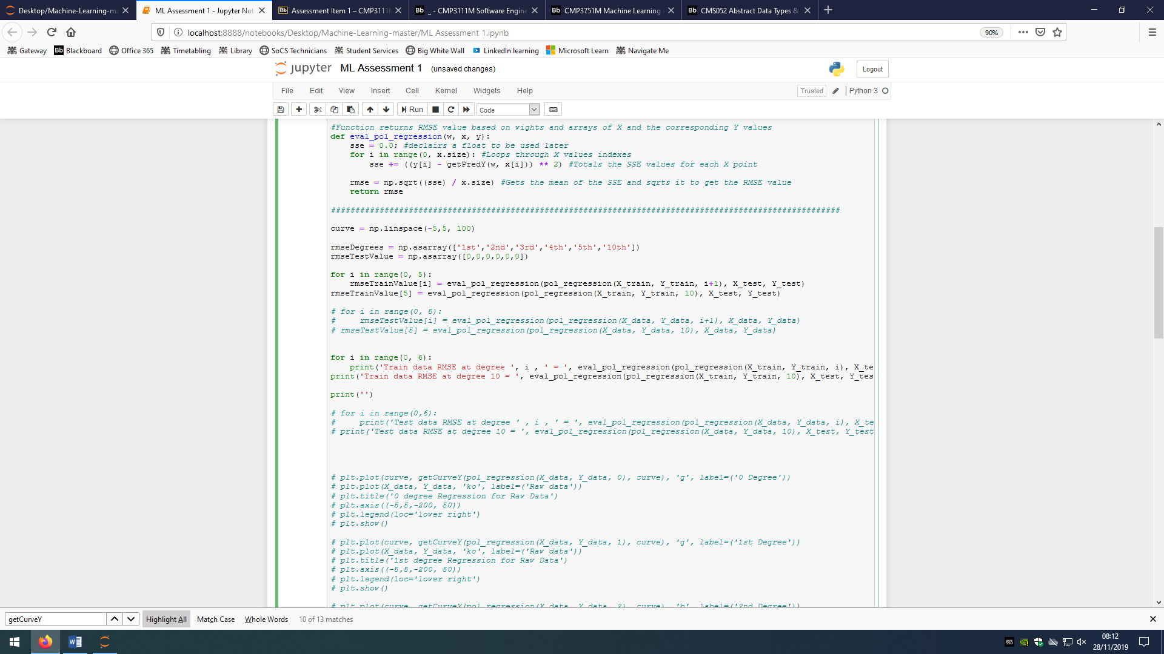

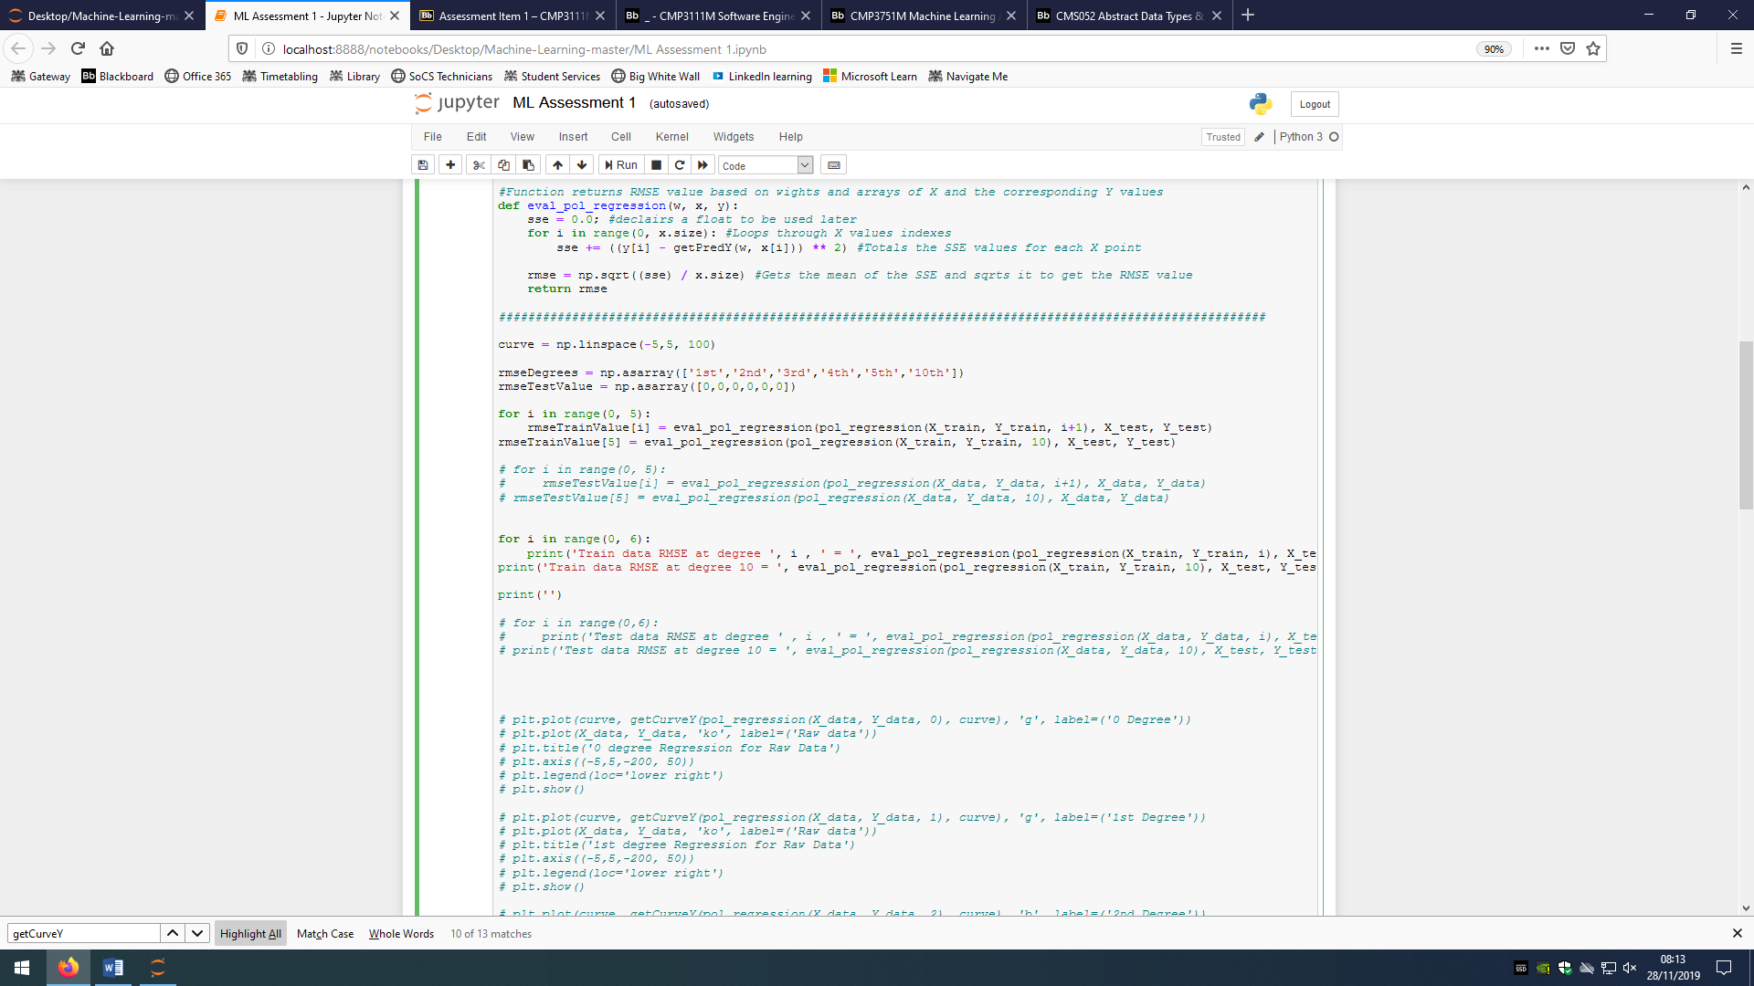The next set of code does the same as the loop above but prints the values instead.

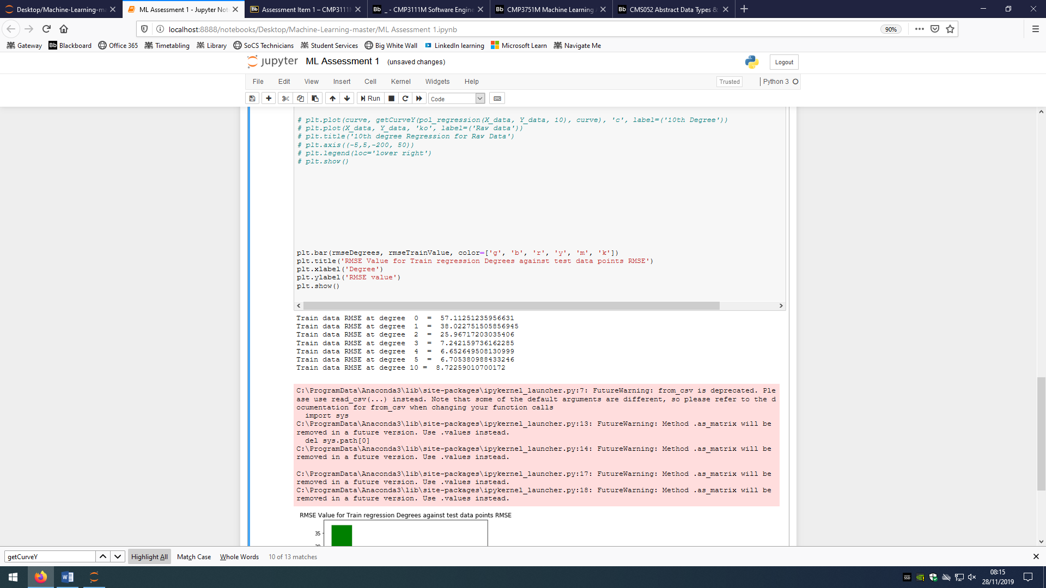Finally, this code produces the graph that the previous code set up the data for.

And the pure results for this work is:

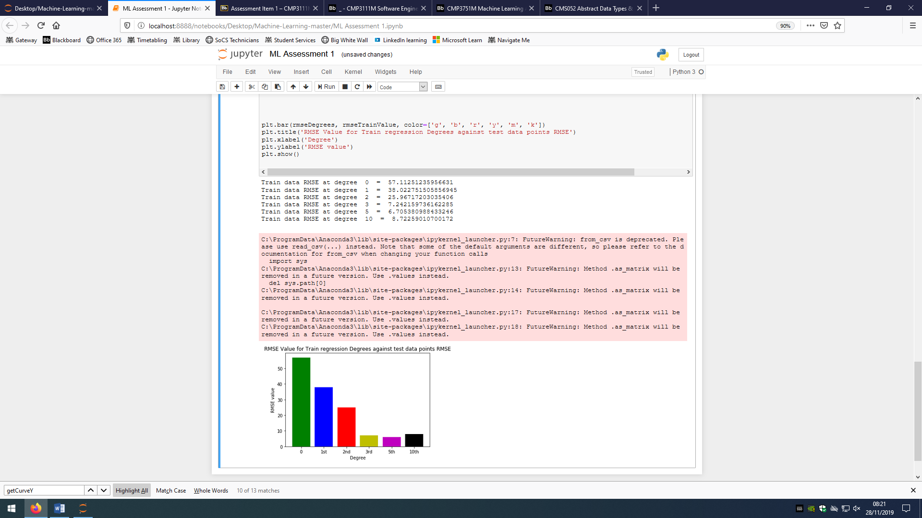

And as a graph:



From these results I can determine that the best line for regression was the polynomial regression line of the 5th degree as it’s the degree with the lowest RMSE value for the test data.

Task 2

Grouping data can be a very easy process if the different clusters are clear, however there are many cases where the data cannot be easily grouped visually and also could be grouped into different numbers of clusters. This is where K-Means comes in, it is an unsupervised clustering algorithm that groups similar data points together and discovers underlying patterns(5?). The objective of K-Means or the Objective function is to group the data in a way that minimizes the total intra-cluster variance.

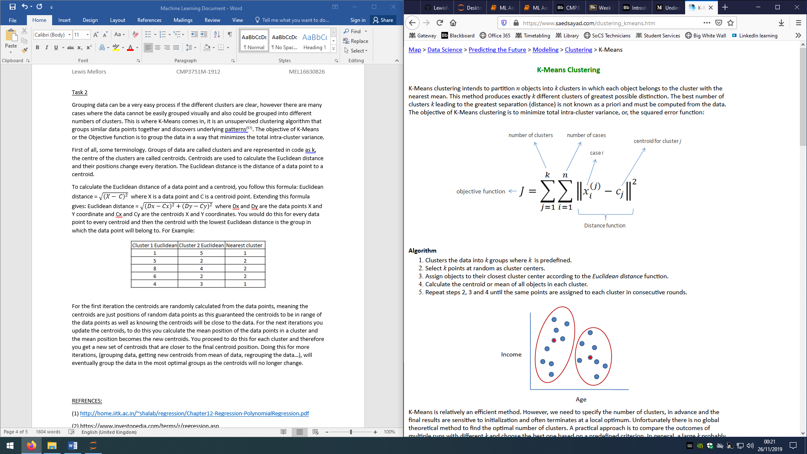

The formula means the total of all the data points to their group’s centroid. This is done after every data point has been grouped into clusters. Another way of thinking of it is to total of all the lowest Euclidean distances.

First of all, some terminology. Groups of data are called clusters and are represented in code as k, the centre of the clusters are called centroids. Centroids are used to calculate the Euclidean distance and their positions change every iteration. The Euclidean distance is the distance of a data point to a centroid.

To calculate the Euclidean distance of a data point and a centroid, you follow this formula: Euclidean distance = $\sqrt{{(X- C)}^{2}}$ where X is a data point and C is a centroid point. Extending this formula gives: Euclidean distance = $\sqrt{{(Dx-Cx)}^{2}+{(Dy-Cy)}^{2}}$ where Dx and Dy are the data points X and Y coordinate and Cx and Cy are the centroids X and Y coordinates. You would do this for every data point to every centroid and then the centroid with the lowest Euclidean distance is the group in which the data point will belong to. For Example:

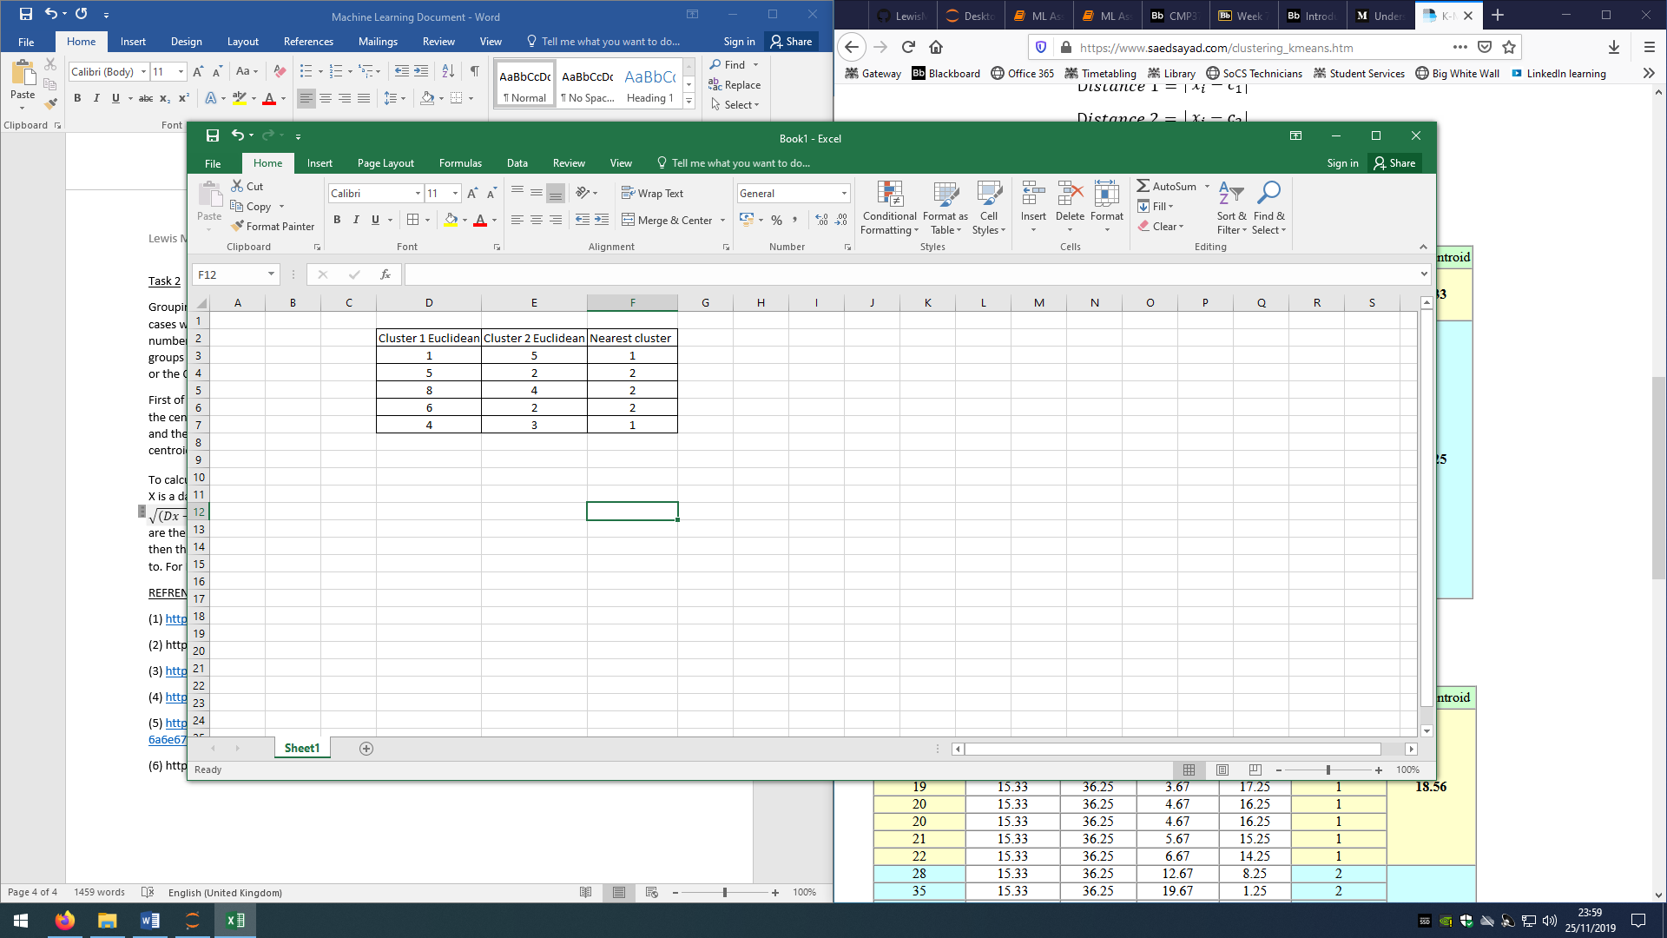

For the first iteration the centroids are randomly calculated from the data points, meaning the centroids are just positions of random data points as this guaranteed the centroids to be in range of the data points as well as knowing the centroids will be close to the data. For the next iterations you update the centroids, to do this you calculate the mean position of the data points in a cluster and the mean position becomes the new centroids. You proceed to do this for each cluster and therefore you get a new set of centroids that are closer to the final centroid position. Doing this for more iterations, (grouping data, getting new centroids from mean of data, regrouping the data…), will eventually group the data in the most optimal groups as the centroids will no longer change.

K-Means is a very quick method of grouping data, it is also low on memory cost as it is an iterative method. K-Means can very easily be scaled to different sized data and can handle large data sets. This method also guarantees to give an output where all data points are in clusters. K-Means also is not affected by different shapes of data and so can be deployed in many different situations.

There are still clear disadvantages of K-Means however. To begin, k or the number of clusters has to be manually chosen and so to get the optimal number of clusters, extra work needs to be done. Since the initial centroids are randomised, the number of iterations it takes to reach the final clusters varies for the same set of data, this means that running K-Means on the same set of data can cause different costs for the same result. Another problem is, because we create new centroids from the mean of the data, outlying data points can have a significant effect on the position of the new centroids and so can effect to overall clustering of the data.

2.2 K-means implementation

Once again the first set of code imports the relevant libraries and gets the data as a dataframe. We then have to manipulate the dataframe to allow us to access the ‘height’ set of data as it is the first column and that is inaccessable in the default state. We then sort the data by the height as that is always our x value. We then separate the data into the individual variables.

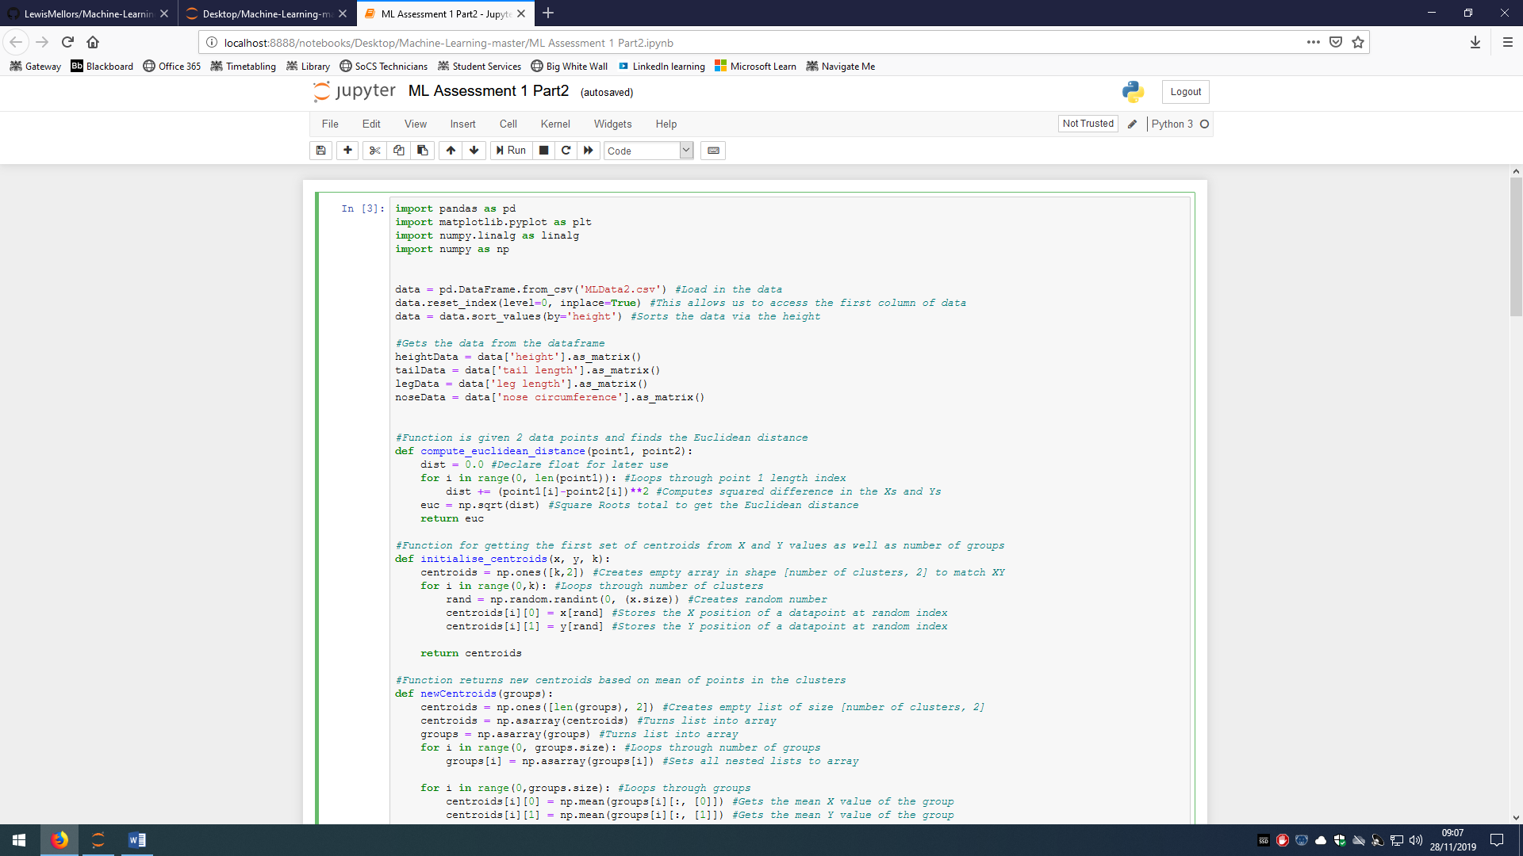

The first function calculates the Euclidean distance for the 2 points.

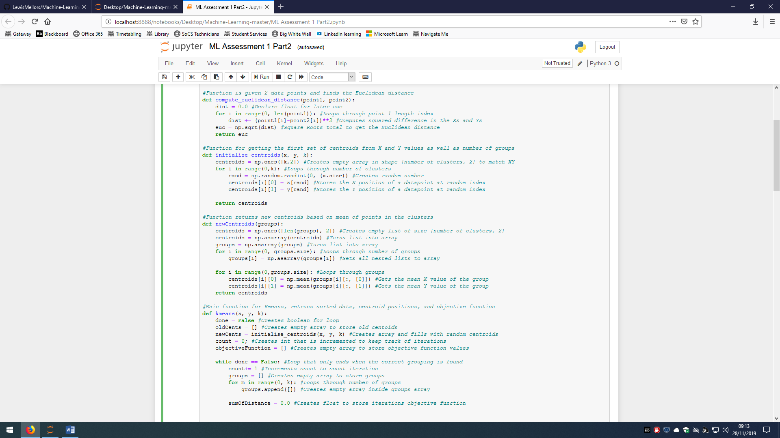

The next function creates the first random centroids. It creates an empty array that stores the X and Y values for the number of groups specified. It then loops through those groups and chooses random data points to mimic their positions.

This function creates the next iterations of centroids from the previously grouped data. It begins by creating a list that stores the X and Y values for the number of groups specified. It then turns that list and the groups list into arrays. It then loops through the nested lists and turns them into arrays. Finally it loops through the grouped data and gets the mean X and Y value and stores it as the new centroid, it does this for each group.



Kmeans is the main function for this code. It gets passed 2 sets of data, the X and Y, and then the number of groups needed. It then creates a Boolean to control the while loop. An empty array is created to hold the old centroids, another array is created but is filled with the random centroids. A counter is made to keep track of the iterations, and another array to hold the values of the objective function. Then the loop begins, it first increments the counter and then creates an array to store the grouped data. It uses a loop to fill that empty array with the number of groups but still empty arrays. A float is created to store the total minimum Euclidean distances for this iteration. It then loops through each data point and calculates all the Euclidean distances for that point and stores them in an array. The array is then searched to find the lowest Euclidean distance index which is then used to add that data point into the specific group. The objective function float is the increased. At the end of the iteration, the objective function is stored and the completion criteria is checked. If it is true then the while loop is ended and the number of iterations is printed. If it is false then it stores the current centroids as the old centroids and new centroids are found using the newCentroids function.

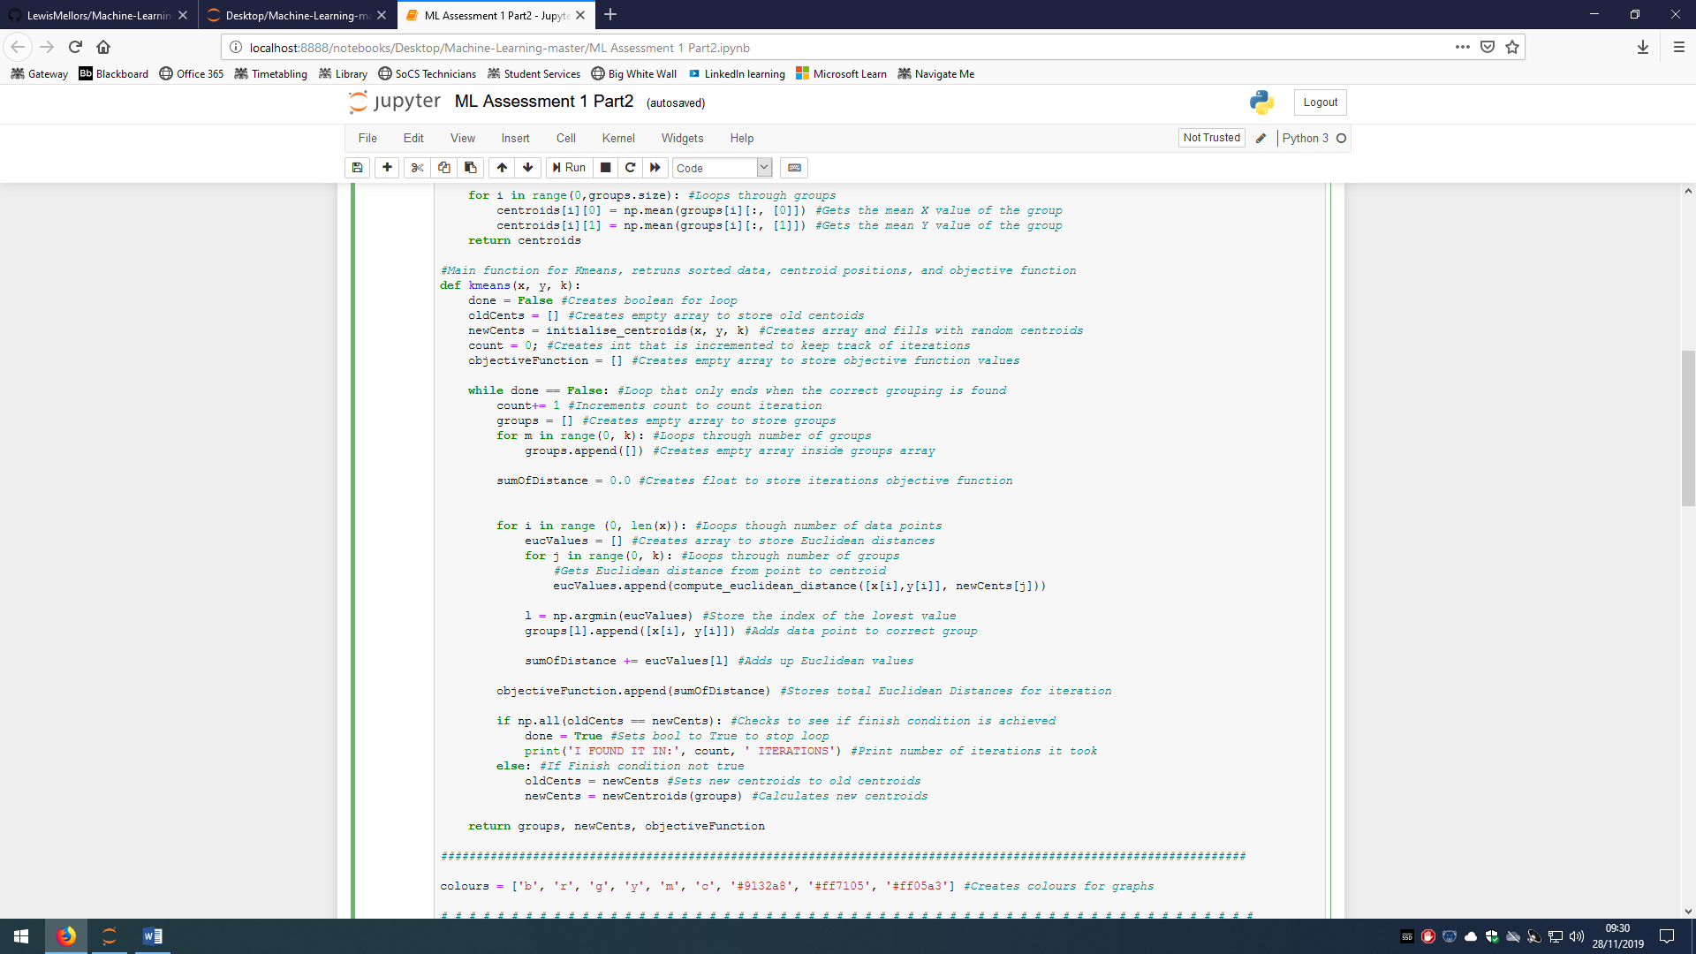

We can now plot the data clusters. First we create an array of colours which means new colours can be automatically selected when plotting many clusters. We then get all the data from the kmeans function and turn the lists into arrays. Another array is created to store the number of itrations that will be used when plotting the objective function. A loop is made to loop throught the clsters and plot all their points with different colours, the centroids are then plot and a title for the graph is made before the graph is shown. A second graph is made to show the iteration number compared to the Objective function. This code shows the graphs for K =2.

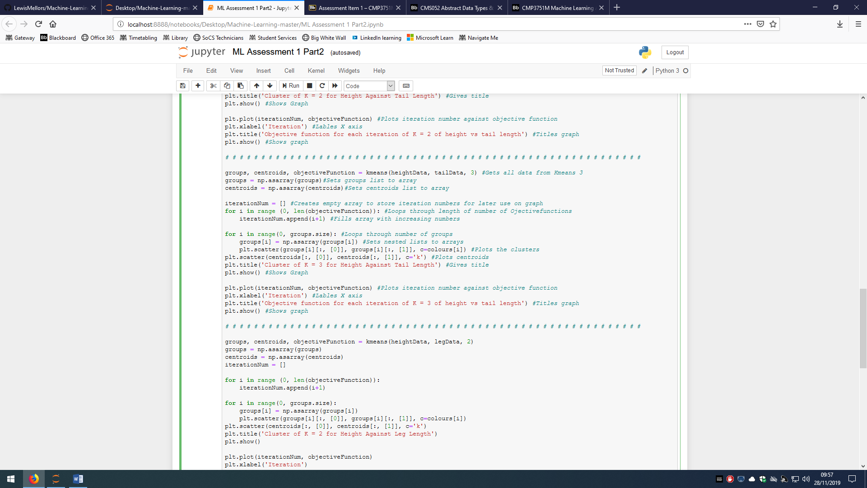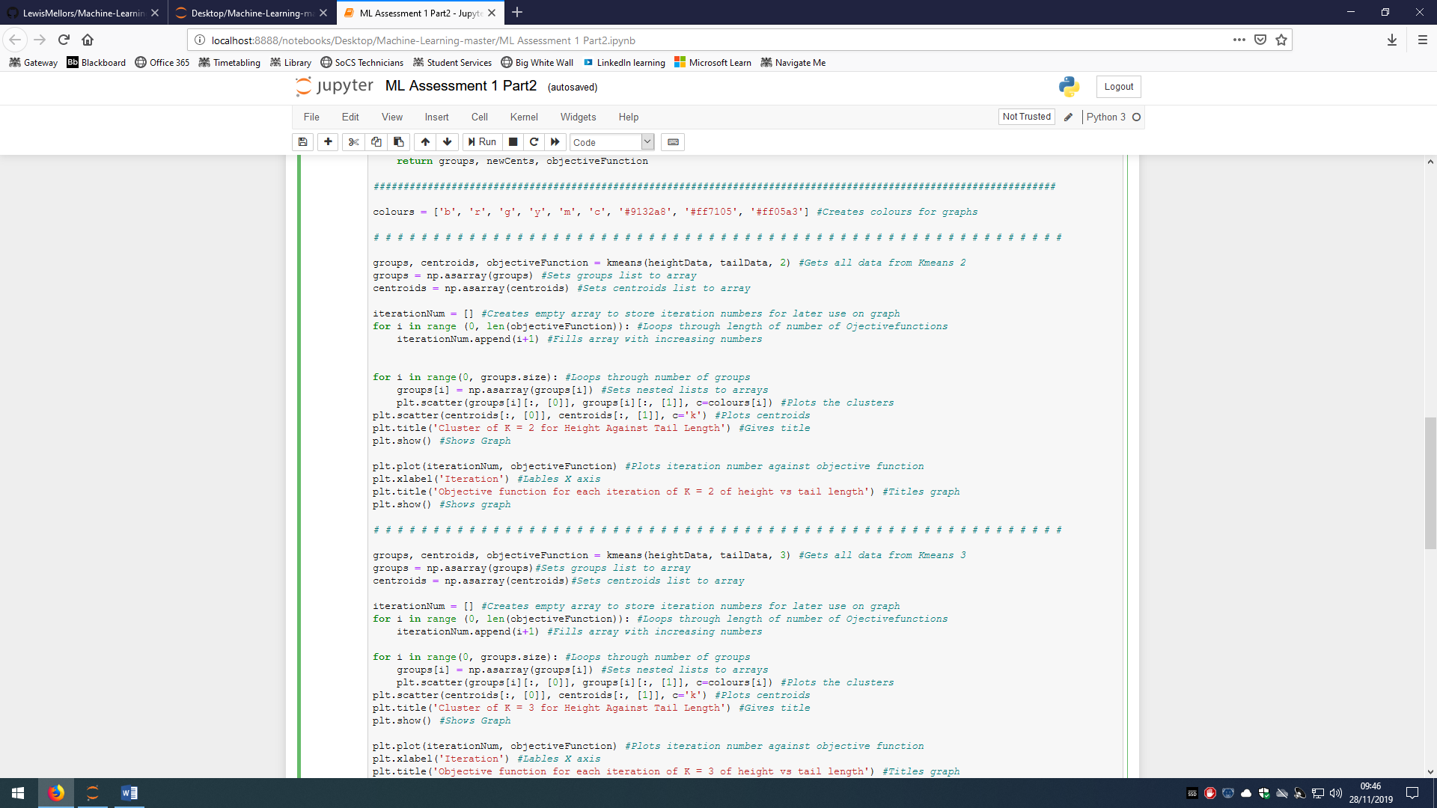This next code shows it for K = 3

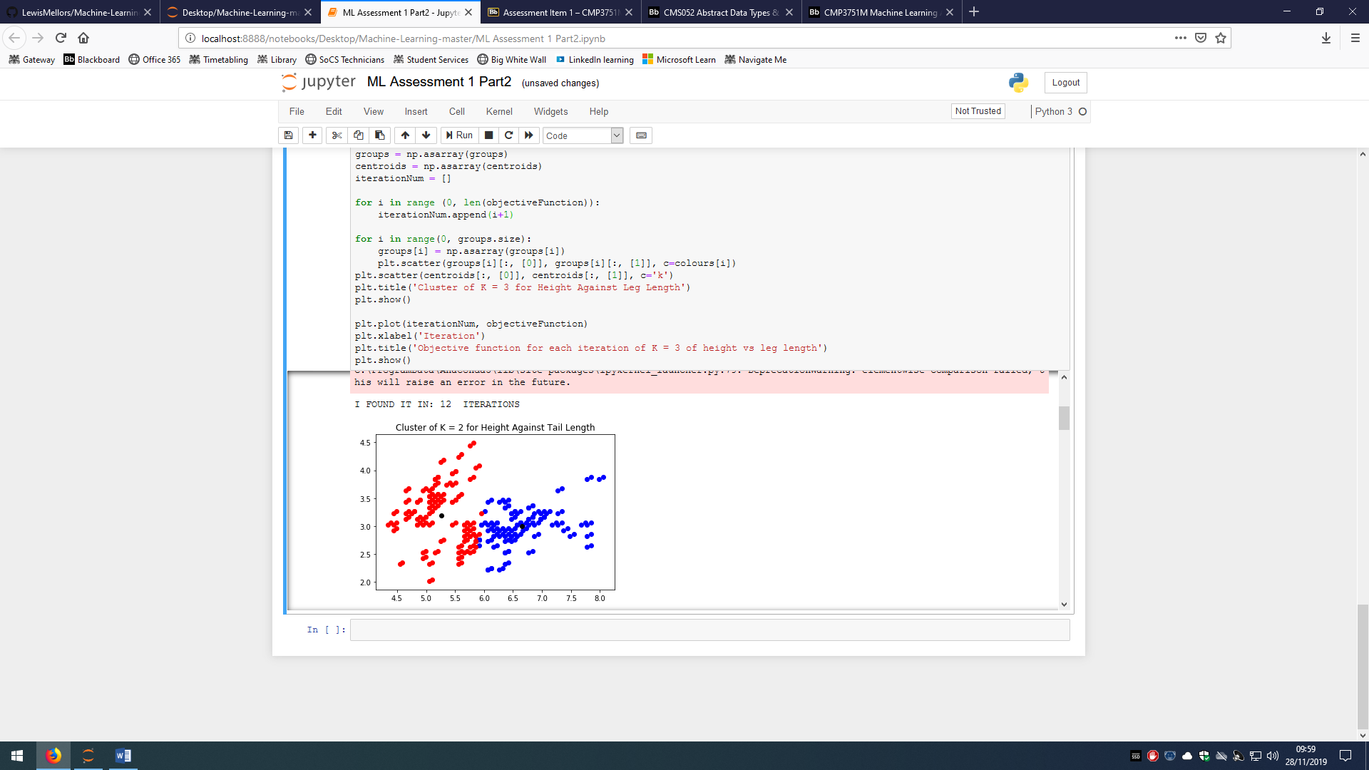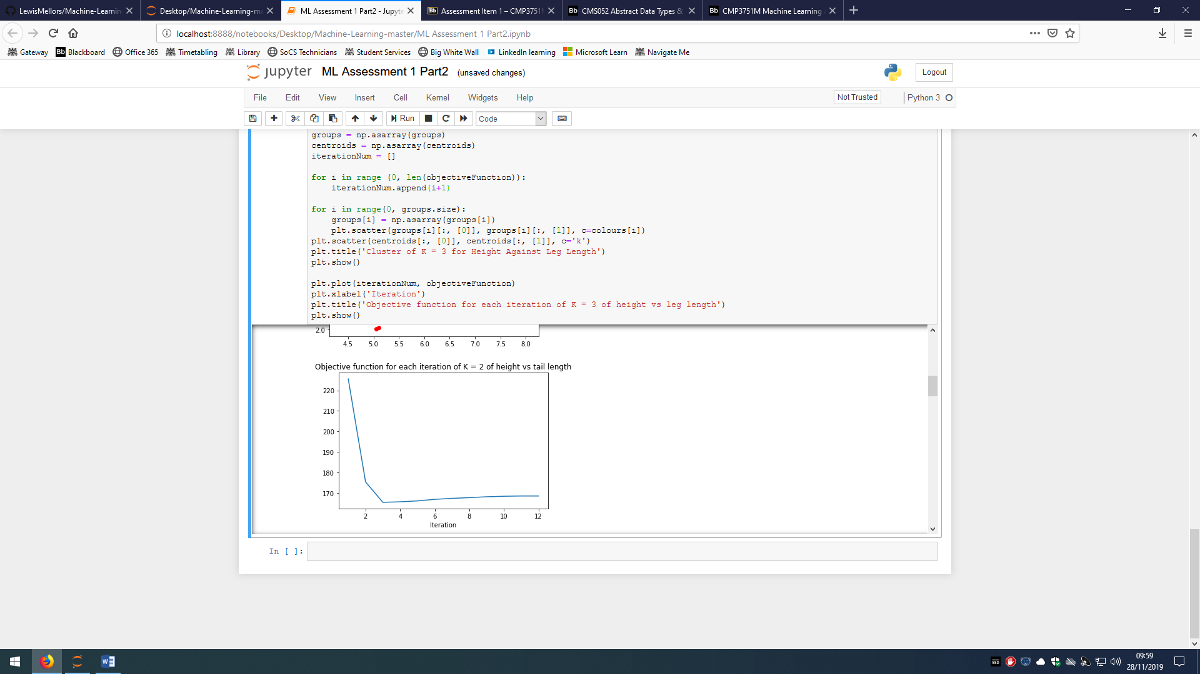The graphs produce:

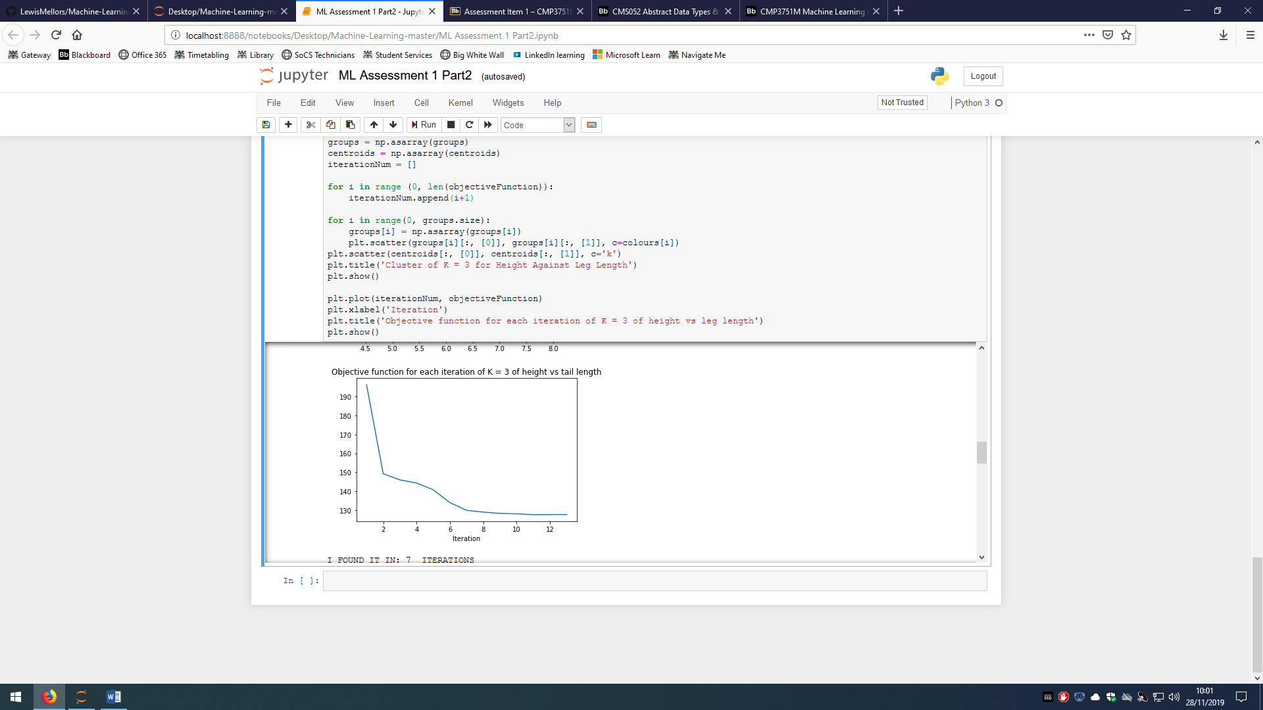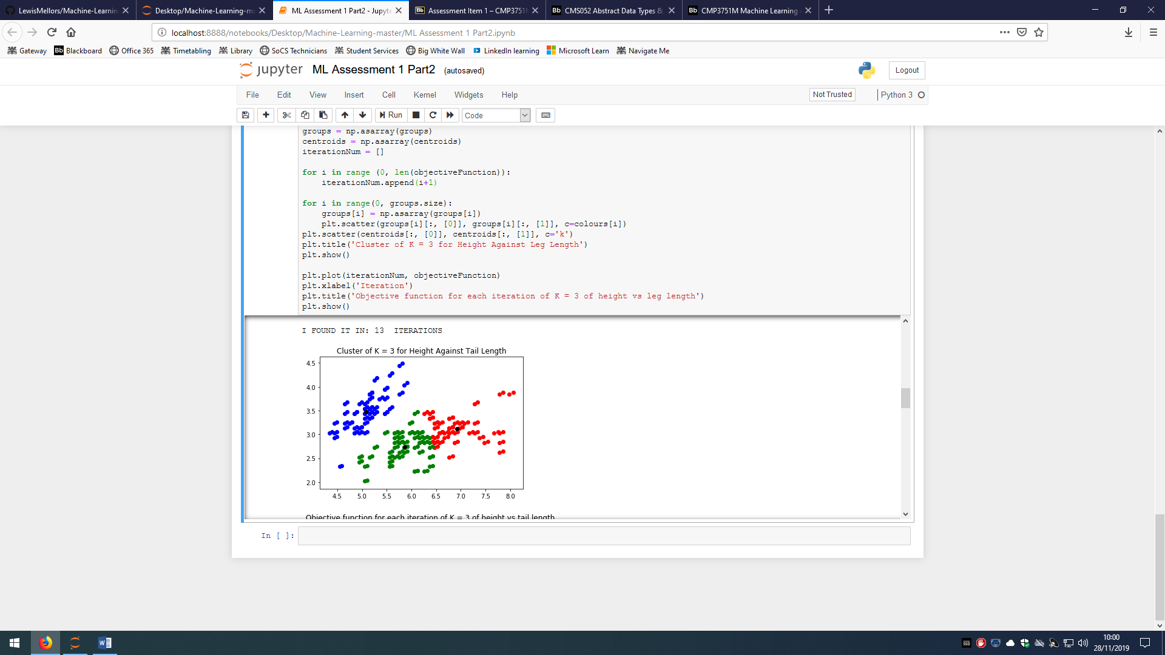

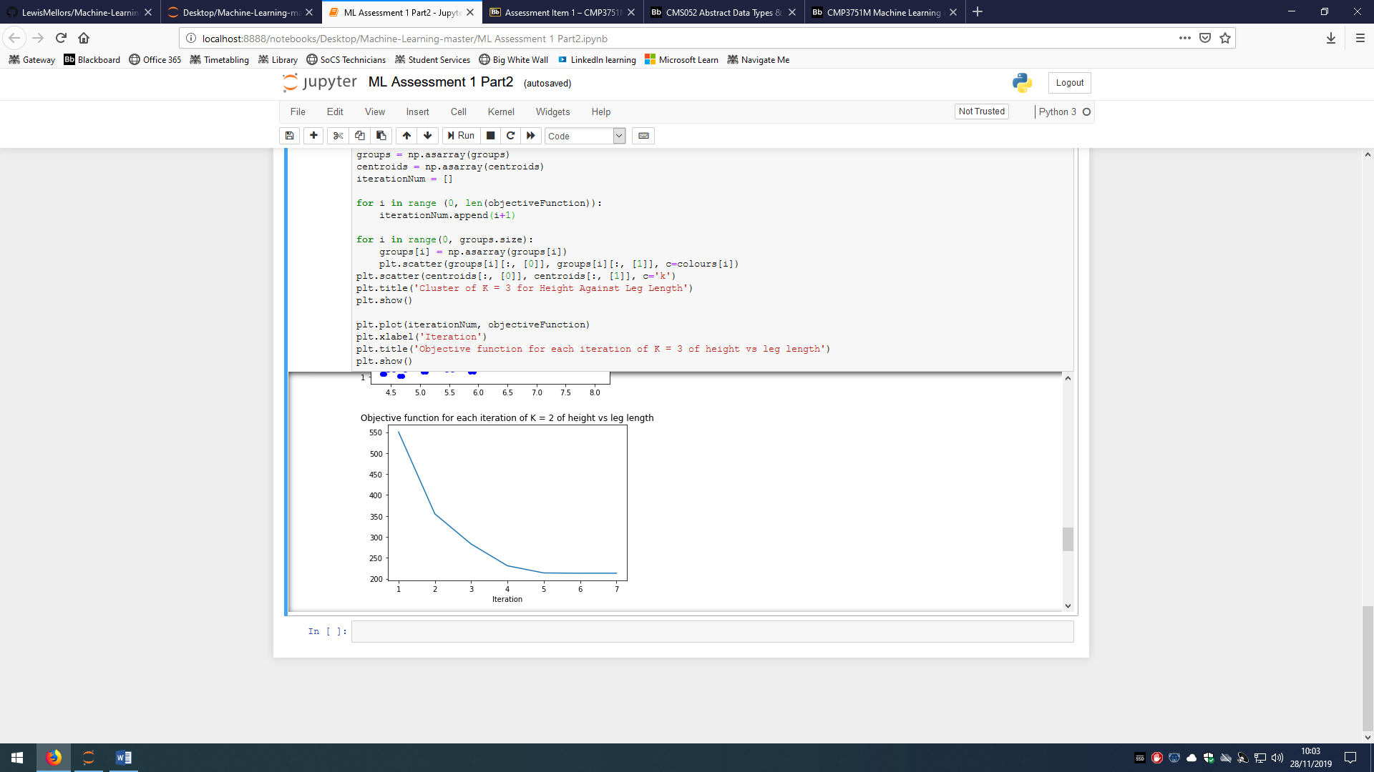

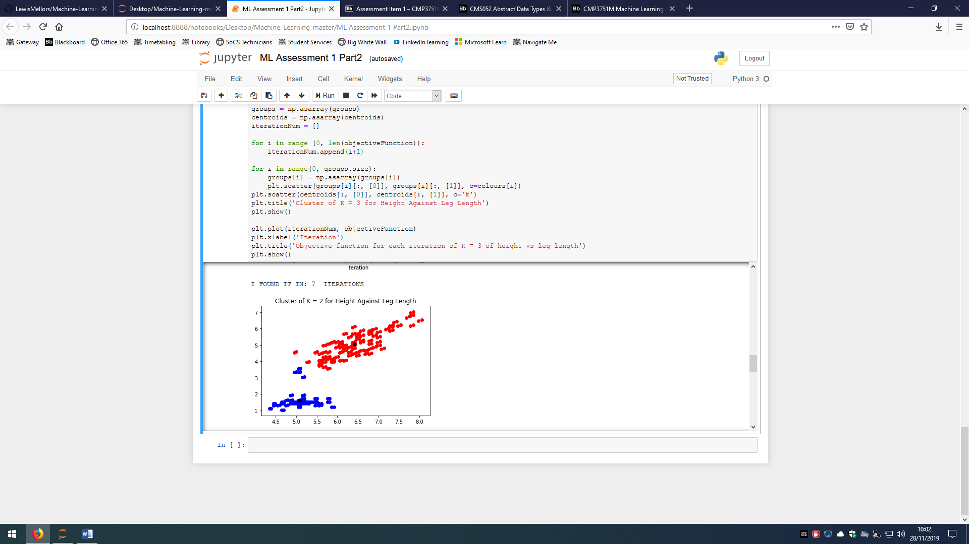

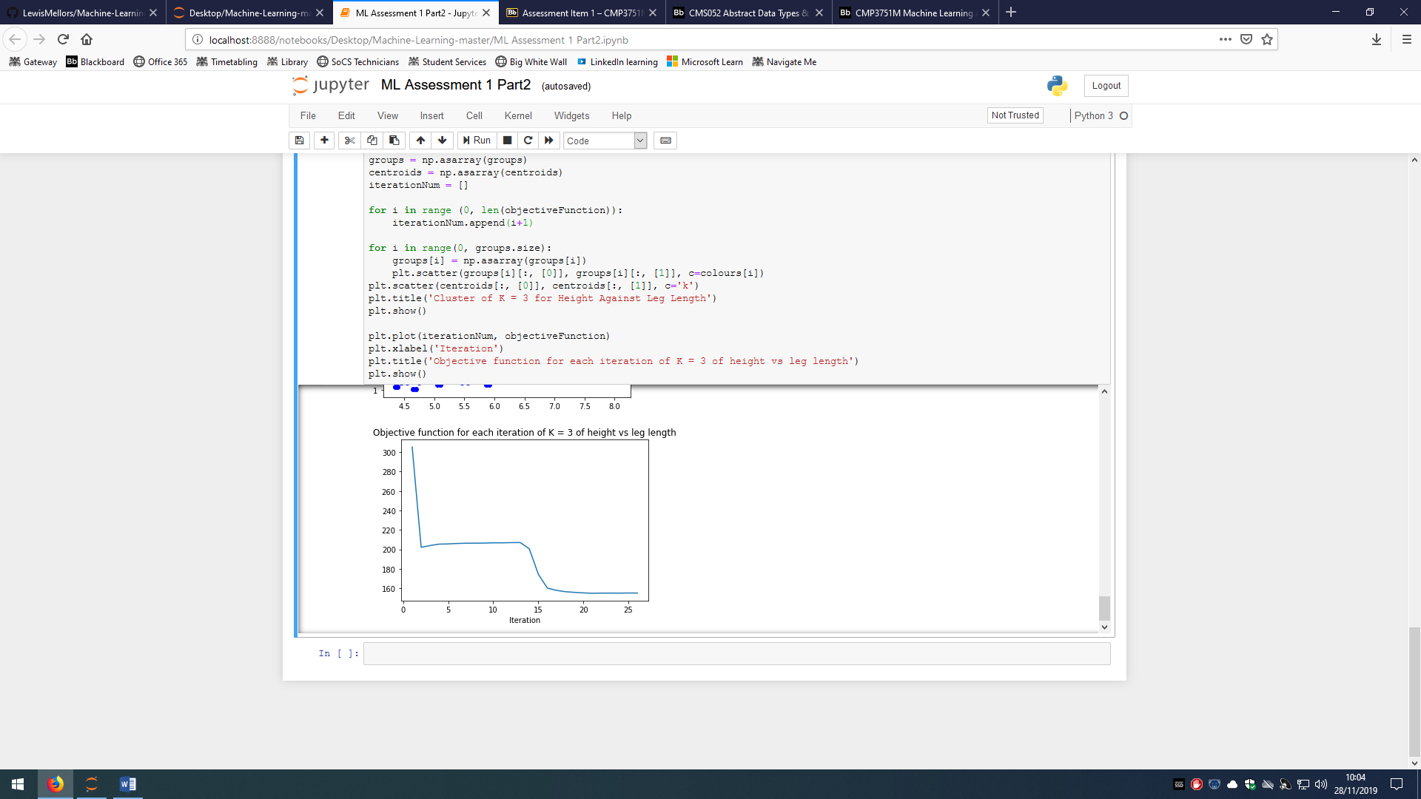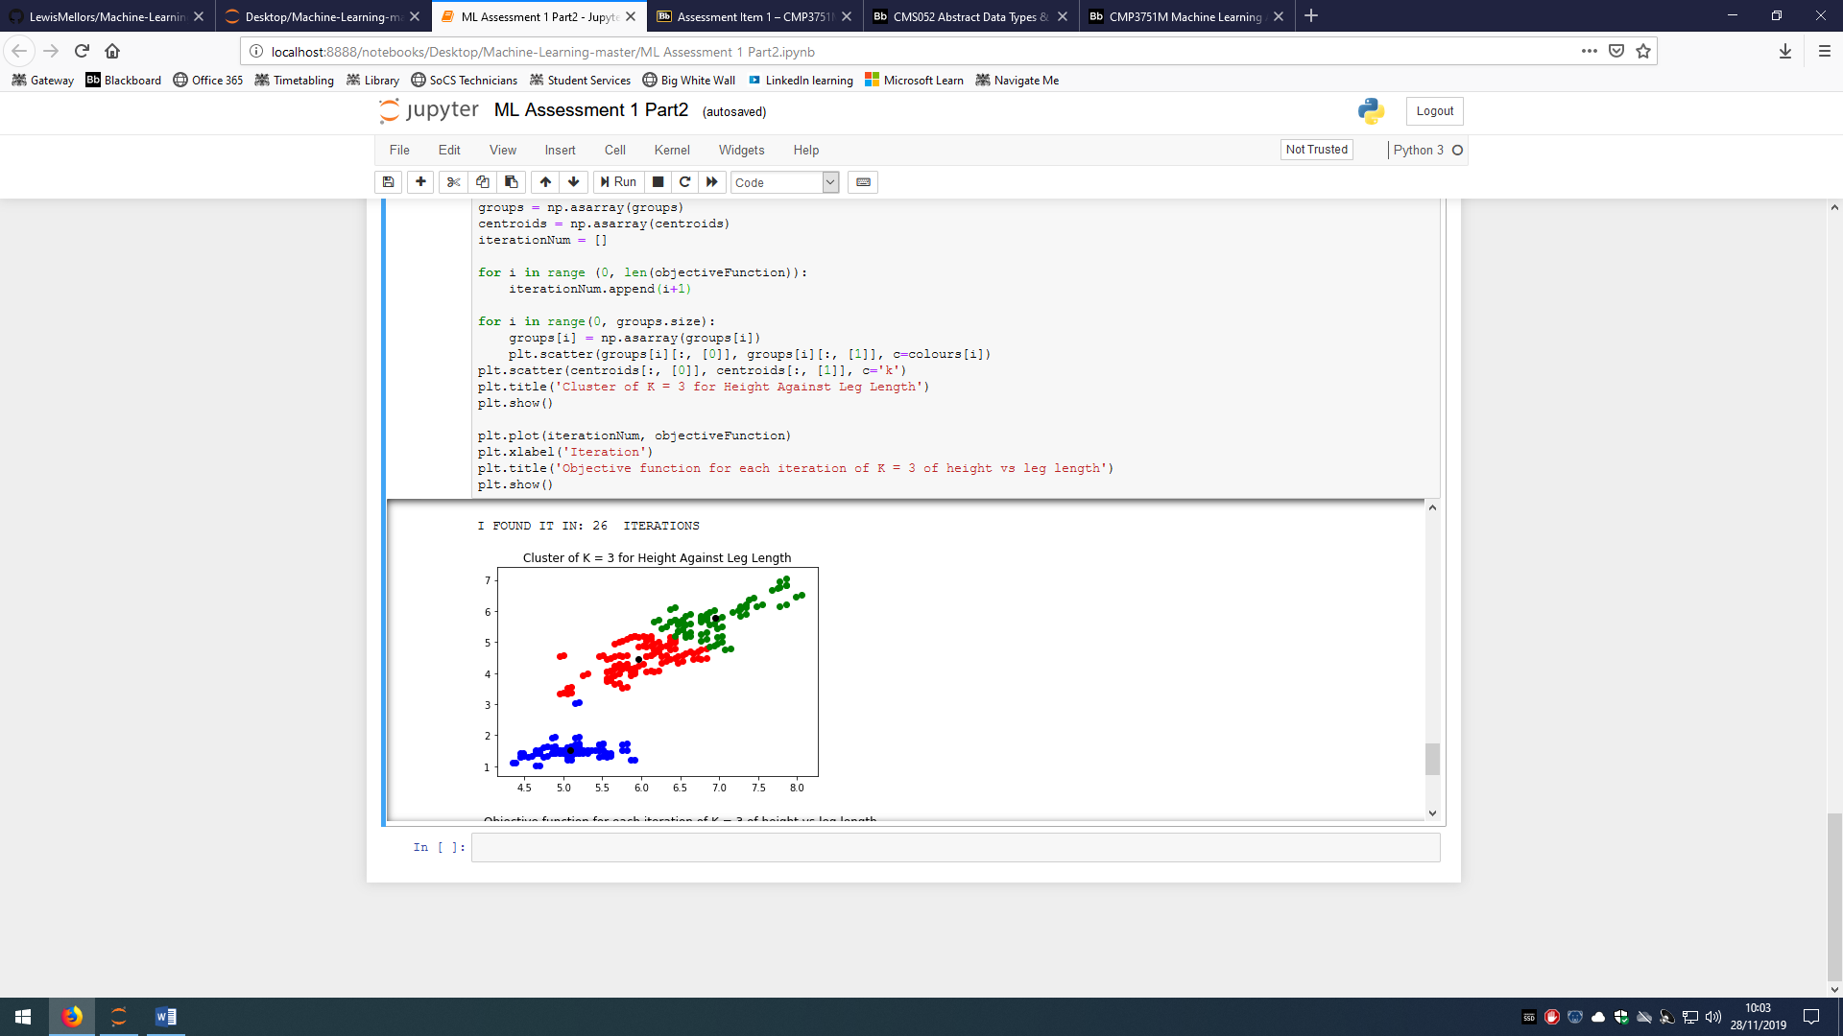

REFRENCES:

1. Shalabh, IIT Kanpur. (N/A) Polynomial Regression Models. India:N/A Available from <http://home.iitk.ac.in/~shalab/regression/Chapter12-Regression-PolynomialRegression.pdf> [accessed 20/11/2019]
2. Investopedia(2019) Regression Definition. New York: DotDash. Available from <https://www.investopedia.com/terms/r/regression.asp> [accessed 20/11/2019]
3. The Analysis Factor(N/A) Assessing the Fit of Regression Models. U.S.A: The Analysis Factor. Available from <https://www.theanalysisfactor.com/assessing-the-fit-of-regression-models/> [accessed 21/11/2019]
4. Statistics By Jim (2017) Overfitting Regression Models: Problems, Detection, and Avoidance. U.S.A: Statistics By Jim. Available from <https://statisticsbyjim.com/regression/overfitting-regression-models/> [accessed 21/11/2019]
5. Towards Data Science(2018) Understanding K-means Clustering in Machine Learning. U.S.A.: Towards Data Science. Available from <https://towardsdatascience.com/understanding-k-means-clustering-in-machine-learning-6a6e67336aa1> [accessed 22/11/2019]
6. Saedsayed(N/A) K-Means Clustering. N/A: Saedsayed. Available from <https://www.saedsayad.com/clustering_kmeans.htm> [accessed 22/11/2019]
7. Google(N/A) k-Means Advantages and Disadvantages. Mountain View: Google. Available from <https://developers.google.com/machine-learning/clustering/algorithm/advantages-disadvantages> [accessed on 23/11/2019]